Barleyhurst Park Primary School



“Lovely Lions look, listen and learn. We can do it, we

will do it, we will do it well.”

'Transport'

Lion Class

Welcome back lovely lions! I hope you all enjoyed the long Easter break. We cannot believe how quickly the year has gone and that we have reached the summer term already. It is a busy half-term ahead, but as ever, we have planned lots of fun and important learning experiences for the children.

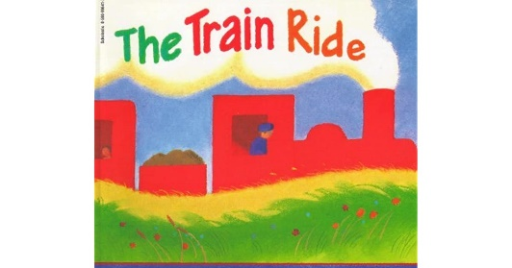**What the children will be learning:**

Communication, Language and Literacy

* Learning to use well-formed sentences when talking in class or with Talk Partners.
* Continue the development of letter-sound recognition and formation.
* Development of reading skills and enjoyment of books.
* Sequencing and retelling ‘Whatever Next’ by Jill Murphy using actions as part of our ‘Talk for Writing’ curriculum.
* 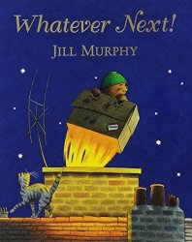Develop their writing skills by writing labels and captions for their own bike or scooter, making their own pirate maps with clues, writing their own story based on the ‘Train Ride’ by June Crebbin.
* Learning to use capital letters and full stops in their writing.
* Learning more focus and high frequency words.

Mathematical development

* Continuing to read, write and order numbers 1 to 20.
* Continuing to count beyond 20.
* Continuing to automatically remember the addition and subtraction facts within 5 and beyond.
* Learning to recognise and continue odd and even number pattern.
* Comparing quantity, using the words greater than, less than, the same as.
* Learning to recognise and use the common 2D and 3D shapes.

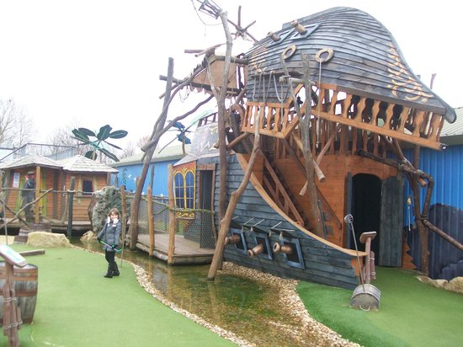Understanding of the world

* Finding out about different forms of transport, in particular trains, bikes, boats, aeroplanes and space rockets!
* Comparing modes of transport now and in the past.
* Travelling by coach to Pirate Crazy Golf course at Abbey Hill! The children will be able to dress up as pirates on the day!
* Exploring the natural world around them and planting seeds.

Expressive arts and design

* Designing and building junk model trains, cars, spaceships etc.
* Construct with different materials.
* Learning to use imagination and newly learnt vocabulary in our role-play areas indoors and outside: the train station, spaceship, pirate ship, road safety area, repair shop.
* Making observational drawings of our bikes and scooters.
* Making a milk bottle space rocket.
* Making a foil pirate ship for our boat race.
* Learning new songs including ‘Journey to Grandpa’s’

[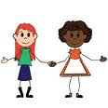](http://www.google.co.uk/imgres?imgurl=http://acclaimclipart.com/free_clipart_images/two_friends_a_black_girl_and_white_girl_holding_hands_0515-0910-2423-5849_SMU.jpg&imgrefurl=http://acclaimclipart.com/free_clipart_images/two_friends_a_black_girl_and_white_girl_holding_hands_0515-0910-2423-5849.html&usg=__HaihRFhbVCucDlj90gRBB8GcZok=&h=300&w=300&sz=22&hl=en&start=19&zoom=1&um=1&itbs=1&tbnid=91t05hbhZWvxNM:&tbnh=116&tbnw=116&prev=/images?q=Friends+clip+art+images&start=18&um=1&hl=en&safe=vss&sa=N&rls=com.microsoft:en-gb:IE-Address&rlz=1I7SMSN&sout=1&ndsp=18&tbs=isch:1)Personal, social and emotional development

* Activities to encourage independence, concentration and confidence.
* Building self-esteem through positive feedback, reward charts, star reader and writer rewards, reward wall (yellow achievement stars from home), keyword certificates and star of the week assemblies.
* Continuing to follow our classroom rules and routines.
* Thinking about our own community.
* Learning to make new friends and share friends.
* Managing emotions.

[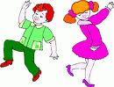](http://www.google.co.uk/imgres?imgurl=http://www.clipartheaven.com/clipart/kids_stuff/images_(g_-_z)/kids_dancing_1.gif&imgrefurl=http://www.clipartheaven.com/show/clipart/kids_stuff/images_(g_-_z)/kids_dancing_1-gif.html&usg=__qBrymsdMnhU6LThzHloY5PqZsAU=&h=374&w=490&sz=11&hl=en&start=12&zoom=1&um=1&itbs=1&tbnid=xbGDvvzp0qppTM:&tbnh=99&tbnw=130&prev=/images?q=dancing+clip+art+images&um=1&hl=en&safe=vss&sa=G&rls=com.microsoft:en-gb:IE-Address&rlz=1I7SMSN&sout=1&tbs=isch:1)Physical development

* Developing fine motor skills through a variety of activities: bead threading, sewing, using finger puppets, cutting with scissors and using loose parts.
* Developing an awareness of space.
* Using large play equipment safely.
* Focusing on ball handling skills.
* Learning to express emotions and linking movements in our dance lessons.
* Developing the understanding of healthy eating.

**Your support**

[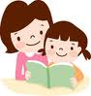](http://www.google.co.uk/imgres?imgurl=http://www.fotosearch.com/bthumb/UNC/UNC203/u29580832.jpg&imgrefurl=http://www.fotosearch.com/clip-art/motherhood.html&usg=__AwIT6uiLkKKb5V8OD1QAvurBaxs=&h=170&w=162&sz=8&hl=en&start=6&zoom=1&itbs=1&tbnid=RDjtjl0pLCXZuM:&tbnh=99&tbnw=94&prev=/images?q=mum+reading+to+a+child+clip+art&hl=en&gbv=2&tbs=isch:1)We hope you can assist your child in their learning by:

* Reading their Monster Phonics e-books with them regularly and writing a brief comment in their reading record.
* Ensuring all items of clothing are named.
* Ensuring that they come to school wearing the correct P.E kit on Tuesdays, Wednesdays and Fridays.
* **Completing the Learning Journal task at home. It is posted through Tapestry every Friday or Monday.**
* Useful websites: [www.topmarks.co.uk](http://www.topmarks.co.uk), (early years section) [www.bbc.co.uk/cbeebies](http://www.bbc.co.uk/cbeebies) , [www.phonicsplay.co.uk](http://www.phonicsplay.co.uk) (phase 2 and 3 games), www.iboard.co.uk (4-7 years).

Thank you for your continued support.

Mrs Wheeler and the Foundation team