**PANTHERS CLASS NEWSLETTER**

**Summer 2024**



Welcome back Year 5! It’s the Summer Term where the days will get longer and (hopefully!) sunnier. We have lots to look forward to this term and have just started on our exciting learning journey. Year 5 staff are very proud of how hard the children worked last term and how much they are using their learning to help them progress.

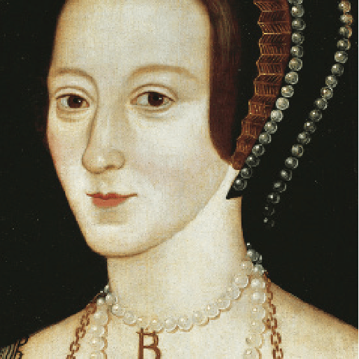

**Off with her head!** What sort of man would order the beheading of his wife? In fact, not just one wife but two wives! Travel back in time to the 15th and 16th centuries and meet the terrifying Tudors, a domineering dynasty that brought about astonishing changes to our country. Discover an opulent court where dancing and singing went hand in hand with swift falls from favour and even swifter falling of heads. Develop your painting skills, solve riddles and remember to protect your precious neck with a large white ruff if you want to survive at Tudor court! Flex your detective muscles and become a criminal investigator. How will you find the accused, innocent or guilty? It’s your turn to take part in one of the most famous trials that the world has ever known – the trial of Queen Anne Boleyn!

**English:** The children will be learning the features of legends as well as writing their own great legends based on the classic 14th century tale of “Gawain and the Green Knight.” They will also be focusing on persuasive writing: this will be a great opportunity for the children to use their skills of persuasion to put across their point of view in a constructive manner. There will continue to be opportunities each week for creative story writing.

**Maths:** We will begin the term by learning about geometry and then moving on to learning about position and movement, including coordinates, translating and reflecting shapes. This will be followed by a focus on measurement involving length, mass, time and temperature as well as area and perimeter. Number work will continue during our Fast Maths lessons.

**Science:** We have a new topic this term – properties and changes of materials. We will be describing different materials, working out how to separate solutions and considering reversible and irreversible changes.

**Computing:** This half term we will be exploring a new area of learning entitled ‘Communication’. This will entail web searching, selecting search results, how searches are influenced and how we communicate responsibly.

Our P.E. sessions are on Mondays and Fridays. On Mondays, children should bring their P.E. kits into school to change into. On Fridays, children should come to school in their P.E. kits as KS2 will be starting athletics on Friday afternoons from 26th April. Also on Fridays, Year 5 will continue to have swimming lessons so will need their swimming kit (trunks or costume, towel) each week. Remember that long hair should be tied up and earrings taken out or covered with micropore tape.

Spellings will be given every Monday ready for the test the following Monday. Please do look at the spellings as many times as possible.

Homework will also be handed out on Thursdays and then should be returned by the following Tuesday.

If your child is uncertain about any of the homework set, they can ask a member of the Year 5 team, before it is due in, for extra support and guidance.

Year 5 have cereals on Wednesday mornings.

Thank you for your continued support and communication. It is so rewarding to see the children’s progress and we can’t wait to see how they get on in this fascinating term.

Mrs Blurton and the Year 5 team.