Summer newsletter June 2023
Year 3, Monkeys
Welcome back to our final half term of Year 3, I can’t believe how quickly the time has passed! I hope you all had an enjoyable half term holiday together.
We have one half term left to cover quite a few units of work so the children will be busy in school until the end of July!

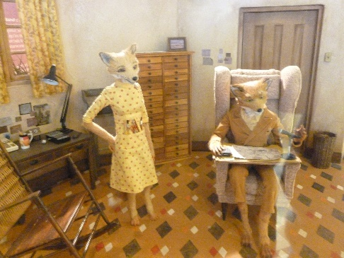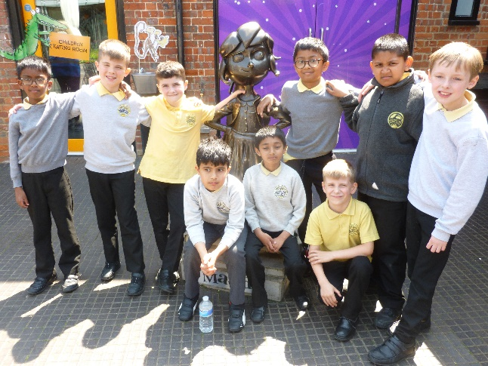
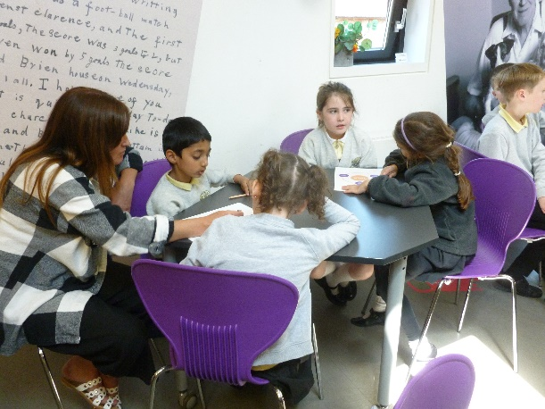

Maths and English
After lots of book studies this year, which the children have thoroughly enjoyed, we will be moving on to some punctuation and grammar work at the start of this term. It is so important that we introduce and consolidate this aspect of the Year 3 curriculum with the children to ensure that they are fully prepared for Year 4.
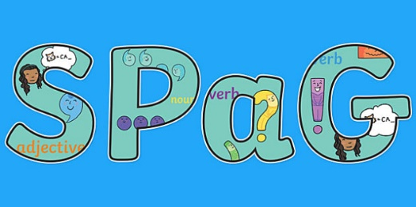
First of all we will reflect on our amazing visit to the Roald Dahl museum, which the children thoroughly enjoyed!

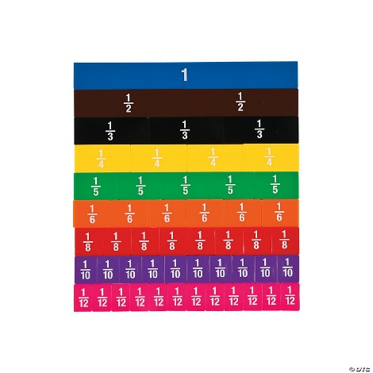
In maths we still have some tricky fraction work to complete but the children were fantastic before the holidays so I’m sure they’ll continue to impress me with their understanding of equivalent fractions. After this unit we will finish the year looking at angles and shapes.

Topic
We had a wonderful half term looking at the Stone Age period of our history before the holiday. Our next focus moves us onto the Bronze and Iron Age which I’m sure the children will enjoy just as much. This class are really artistic and I have always been so impressed with what they produce in art based topic lessons.

Pen licences
The children are working super hard to receive their pen licences at the moment in class and I am very impressed with their efforts to join their handwriting. More children are becoming confident with joining in all writing now and extra practise when they are completing homework tasks would be beneficial!
I look forward to another fun half-term with my Monkey class!
Mrs Burns

