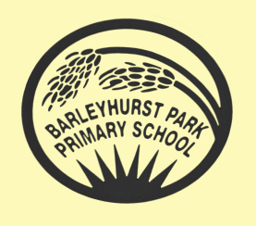
YEAR 2
Giraffes

NEWSLETTER NOVEMBER 2025
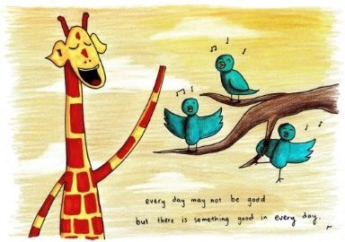
Autumn 2
We hope you have had a great half term break together!

Thank you to all who attended the parents’ evening meetings last term,
it was great to meet you all properly. I hope you left feeling proud!
The final week was so much fun with our Book Week, and we loved seeing
all the children enjoying being cosy in their pyjamas.

Beachcombers
This half term we will continue with our topic and will investigate coasts and erosion of coastlines. In History we will continue to look at Victorian seasides.

English
In English we will be using lots of exciting poems alongside information books and other stories with familiar settings to help us to learn more about our seaside and coasts.

Maths
In Maths, we will be revising multiplication and then moving on to division and measurement. We will also consolidate our addition and subtraction knowledge and apply these skills in solving worded problems. Please keep practising times tables at home as it really is noticeable in school.

Weekly Routines
PE continues to be on MONDAYS, TUESDAYS and FRIDAYS- children should come to school wearing their PE kit. There have been quite a few children who have not had their earrings covered with tape, please ensure they have some tape in school or they will need to take their earrings out for the lesson.

Spellings will be sent home on Mondays and the children will be tested on the Friday. This homework is improving but it is very clear when the children haven’t learnt their weekly lists and they can be disappointed with their score!

Homework is set on a Thursday and is due in by the following Tuesday. I am so impressed with their homework so far but again we have a few children who need a little prompting to hand in their work on time.



How can you help your child?
- Listen to them read each week Please make a note in their reading record when they have read to you as they love getting stickers for reading at home (this can be your signature or a short comment).
- Ask them questions about what they have read.
- Encourage them to practise their spellings.
- Support them in completing their homework if they need help.
- Practise 2, 5, 10 times tables as much as possible as we are times tables superstars in Year 2!

Key Dates:
- 3rd December – Christmas Fair
- 9th and 10th December – Nativity performances
- Friday 19th December – Last day of the half term.

Please do not hesitate to ask any questions, or to have a chat about any concerns you might have. I just ask that you wait until the class is dismissed so I can ensure everyone is safely with their adults.

I am so pleased with the progress the children are making, and I thank you for your ongoing support.
Mrs Burns

