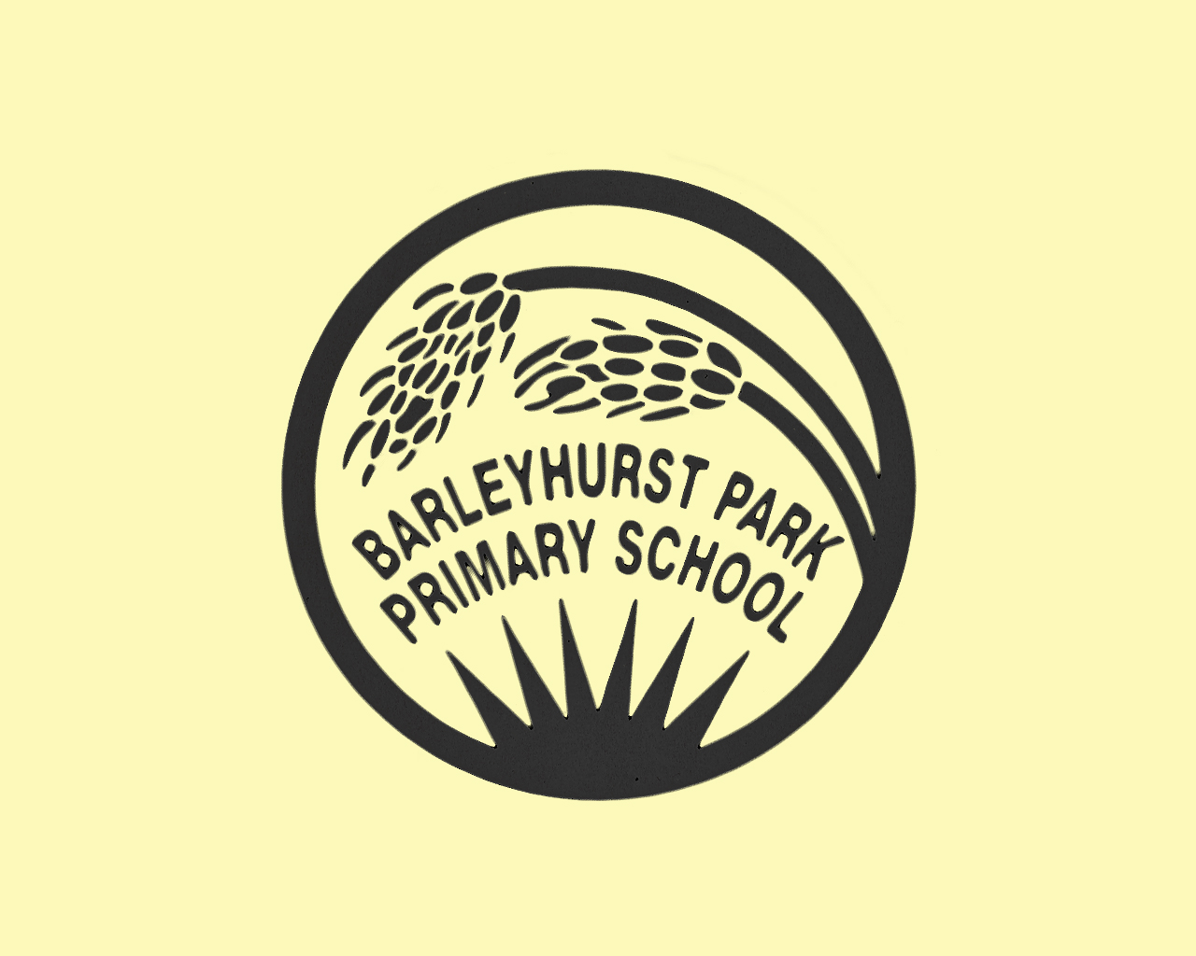
Morning Club
Registration Form
(Please complete all sections)
Pupil Surname: ………………………………………… | Pupil Forename: ……………………………………
Name known as (if different): ………………………………………………………………………
Date of Birth (DD/MM/YY): ……………………………. | Male / Female (please circle)
Year Group / Class name: ……………………............
Address: .....................................................................................................................................................

………………………………………………………………………………………………………………………………………………………………….
Postcode: …………………… |  | Home telephone number: …………………………….

EMERGENCY CONTACTS : please give details of all persons who have parental responsibility and anyone else you wish to be contacted in an emergency. Where possible we need two points of contact.

Please list in order of priority
- Name: …………………………………………………… | Relationship to pupil: ………………………………………….
Address (if different to pupil) | Home tel: ……………………………………………………………..
…………………………………………………………………………… | Mobile tel: ……………………………………………………………
…………………………………………………………………………… | Work tel: ……………………………………………………………...
- Name: …………………………………………………… | Relationship to pupil: ………………………………………….
Address (if different to pupil) | Home tel: ……………………………………………………………..
……………………………………………………………………………. | Mobile tel: ……………………………………………………………
……………………………………………………………………………. | Work tel: ……………………………………………………………...
- Name: …………………………………………………… | Relationship to pupil: ………………………………………….
Address (if different to pupil) | Home tel: ……………………………………………………………..
…………………………………………………………………………... | Mobile tel: ……………………………………………………………
………………………………………………………………………….. | Work tel: ……………………………………………………………...

MEDICAL DETAILS
Name of Doctor: …………………………………………. | Tel No: …………………………………….
Address: .....................................................................................................................................................

………………………………………………………………………………………………………………………………………………………………….
Postcode: …………………………….……

Does your child have any medical conditions, eg asthma, epilepsy, hay fever, hearing loss?

__________________________________________________________________

Does your child suffer from any allergies or intolerances? If so please give FULL details:

__________________________________________________________________

__________________________________________________________________

CONTRACT OF AGREEMENT

In general the policies of Barleyhurst Park Primary School govern the running of the Morning Club. In addition the points below should be read and understood.

- Spaces are limited and therefore places must be booked in advance with the Morning club directly or via the school office.
- If a pupil contravenes the expectations of Morning club it could result in exclusion from the club.
- All payments must be made in advance. Entrance to the club is not allowed without payment.
- In case of illness, refunds will only be given if the school is informed before 8.00am. All other cancellations will only be refunded if at least 24 hours notice is given.

Signed ………………………………………………………………….(Parent/Guardian) Date …………………………

