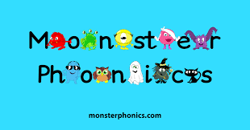

At Barleyhurst Park Primary School, we follow the government approved, systematic synthetic phonics programme ‘Monster Phonics’ for the teaching of phonics.
Sessions run for 25 minutes a day in classes and children are taught to apply their phonics skills and improve their fluency through the Monster Phonics characters and story books used during these sessions. Although first quality teaching is our priority, the children’s progress in phonics is closely tracked and individuals are regularly assessed and regrouped as appropriate. Keep up sessions are timetabled each day to ensure all children can keep up with the sounds being taught.
Predominantly this scheme is used with our Key Stage One children, but the resources and interventions are also used in lower Key Stage Two for individual groups of children.
PHONICS MATCHED BOOKS
All our families have access to Monster Phonics ebooks and parents are encouraged to support their children in reading these books each week. Home reading books are phonics based and match our phonics programme to ensure books closely match the sound being taught in lessons. Our suggested system for parents when listening to their children read is:
Read number 1: Read and decode together.
Read number 2: Read for fluency.
Read number 3: Read for expression and understanding.
There are also activities and questions for them to complete in the front and back of the books.
Children progress through the reading levels in line with our phonics programme and this is again closely tracked.
Once the children in Year 2 are reading stage 10 Monster Phonics books with a minimum of 90% accuracy they move onto colour banded books where they can practise more comprehension skills.

