“Lovely Lions look, listen and learn. We can do it, we
will do it, we will do it well.”

Welcome back lovely lions! I hope you all enjoyed the long Easter break. We cannot believe how quickly the year has gone and that we have reached the summer term already. It is a short half-term ahead, but as ever, we have planned lots of fun and important learning experiences for the children.
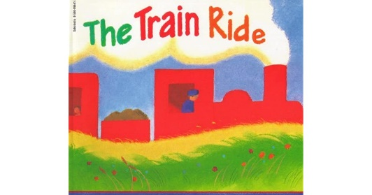
What the children will be learning:
Communication, Language and Literacy
- Learning to use well-formed sentences when talking in class or with Talk Partners.
- Continue the development of letter-sound recognition and formation.
- Development of reading skills and enjoyment of books.
- Sequencing and retelling ‘Whatever Next’ by Jill Murphy using actions as part of our ‘Talk for Writing’ curriculum.
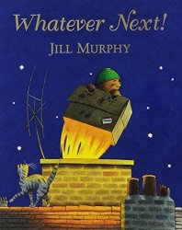
- Develop their writing skills by writing labels and captions for their own bike or scooter, making their own pirate maps with clues , writing their own story based on the ‘Train Ride’ by June Crebbin.
- Learning to use capital letters and full stops in their writing.
- Learning more key words.

Mathematical development
- Continuing to read, write and order numbers 1 to 20.
- Continuing to count beyond 20.
- Continuing to automatically remember the addition and subtraction facts within 5 and beyond.
- Learning to recognise and continue odd and even number pattern.
- Comparing quantity, using the words greater than, less than, the same as.
- Learning to recognise and use the common 2D and 3D shapes.

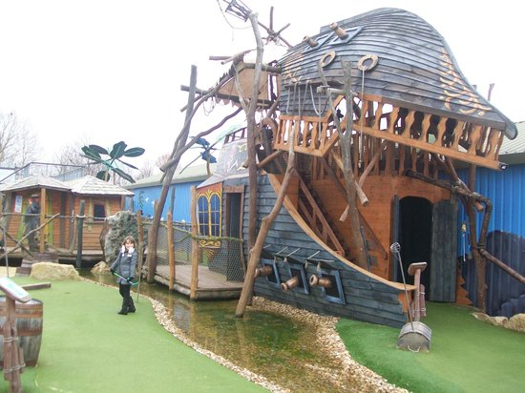
Understanding of the world
- Finding out about different forms of transport, in particular trains, bikes, boats, aeroplanes and space rockets!
- Comparing modes of transport now and in the past.
- Travelling by coach to Pirate Crazy Golf course at Abbey Hill! The children will be able to dress up as pirates on the day!
- Exploring the natural world around them and planting seeds.
Expressive arts and design
- Designing and building junk model trains, cars, spaceships etc.
- Construct with different materials.
- Learning to use imagination and newly learnt vocabulary in our role-play areas indoors and outside: the train station, space ship, pirate ship, road safety area, repair shop.
- Making observational drawings of our bikes and scooters.
- Making a milk bottle space rocket.
- Making a foil pirate ship for our boat race.
- Learning new songs including ‘Journey to Grandpa’s’

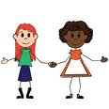
Personal, social and emotional development
- Activities to encourage independence, concentration and confidence.
- Building self-esteem through positive feedback, reward charts, star reader and writer rewards, reward wall (yellow achievement stars from home), keyword certificates and star of the week assemblies.
- Continuing to follow our classroom rules and routines.
- Thinking about our own community.
- Learning to make new friends and share friends.
- Managing emotions.

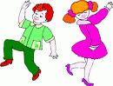
Physical development
- Developing fine motor skills through a variety of activities: bead threading, sewing, using finger puppets, cutting with scissors and using loose parts.
- Developing an awareness of space.
- Using large play equipment safely.
- Focusing on ball handling skills.
- Learning to express emotions and linking movements in our dance lessons.
- Developing the understanding of healthy eating.

Your support
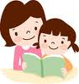
We hope you can assist your child in their learning by:
- Reading their Monster Phonics e-books with them regularly and writing a brief comment in their reading record.
- Ensuring all items of clothing are named.
- Ensuring that they come to school wearing the correct P.E kit on Mondays, Wednesdays and Fridays.
- Completing the Learning Journal task at home. It is posted through Tapestry every Friday or Monday.
- Useful websites: www.topmarks.co.uk, (early years section) www.bbc.co.uk/cbeebies , www.phonicsplay.co.uk (phase 2 and 3 games), www.iboard.co.uk (4-7 years).
Thank you for your continued support.
Mrs Wheeler and the Foundation team

