Monkeys Newsletter – Summer 2024
Welcome back!
It’s been lovely to welcome the children back to school for the Summer Term although they appear to have brought some rain with them! Hopefully it isn’t here to stay so we can get on the field and enjoy some more outdoor learning.

The Curriculum
In English we have just started a new story called ‘Fantastic Mr Fox’ which the children seem to be enjoying already. They are a class who love being read to! In our lessons we will explore the style of the author again and start to look at how we plan and organise letters.
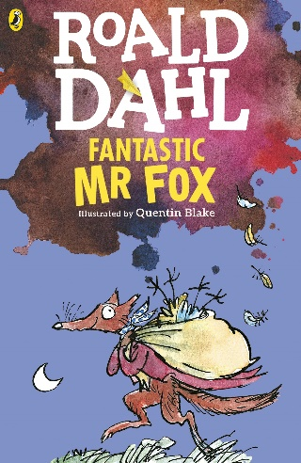

The Maths No-Problem work books will continue to be used for our maths lessons this term. Our initial focus will be graphs and tables followed by a deep dive into fractions! In the last term we were making good progress with their telling of the time but lots of extra practise is still needed. Any support at home would be fantastic as it is such an important life skill that they need.

In Topic, our new unit is ‘Tribal Tales’ and I’m sure the children will astonish me with their wealth of understanding about prehistoric times. During the first half term we will focus on the housing and tools that were an important part of this historical period.
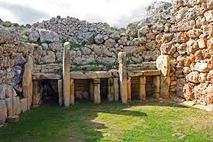
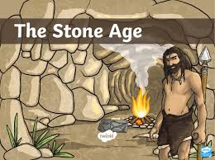

Behaviour in class continues to be good and I appreciate the support with minor issues which arise. Homework is being completed but a couple of children are handing the tasks in late or not completing spelling homework which is a shame as this stops the class from receiving celebratory marbles. Please encourage the children to make sure homework is handed in by Tuesday where possible. A gentle reminder about remembering a change of shoes for Forest School too!
Many thanks,
Mrs Burns

