YEAR 2

**Giraffes**

NEWSLETTER APRIL 2025

SUMMER 1

Welcome to the Summer Term of this school year. We hope you had a great spring break and enjoyed spending time in the sunshine (and rain) with your family and friends. It was lovely to see all the children coming back to school enthusiastically and ready for new learning, which we are all very excited about.

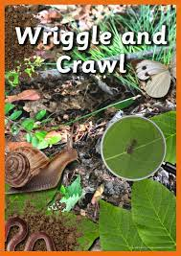

**Wriggle and Crawl**

Our topic for this term is ‘Wriggle and Crawl’ and we will kick start our new topic by finding a variety of insects around our school grounds! Throughout the topic we will be gaining lots of knowledge and understanding about minibeasts, their habitats and what they need to survive, so we can answer a range of questions.

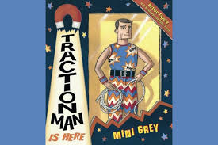

In **English** we will be reading ‘Traction Man’ by Mimi Grey which the children will love. We will be writing for different purposes, such as stories, lists and leaflets, instructions, reviews, and information texts.

In **Maths**, we will continue to consolidate our knowledge about fractions, and we will be learning how to tell the time. Any help with telling the time on an analogue clock will really help their progress with this.

In **Science**, we will consolidate our learning about living things and we will be working scientifically to investigate and learn about animals, including humans.

In **History** we will focus on how life has changed over the decades, starting with the 1950s. We will be looking at how things such as clothes, toys, homes, schools and technology has changed. If you have anything at home from any of the decades (1950s-1990s) then, please do send them in and we will look at them in our History lessons.

In **Design and Technology** we will be designing and creating a healthy sandwich wrap.

In **PE** Giraffes will be enjoying net wall games and some outdoor athletics. Please be sure to send them to school with the **correct** PE kit on Tuesdays, Wednesdays and Thursdays. Earrings **must** be removed or covered with micropore tape before coming to school please as I do not have any spare tape in school.

**How can you help your child?**

• Listen to them read and fill in their reading logs as they love to get stickers for reading at home!

• Encourage them to practice their spellings every day.

• Support them in completing their homework.

• If your child is unsure about how to complete a piece of homework, then encourage them to

speak to an adult at school before it’s due in.

• Provide a named water bottle for them to use in class.

**Weekly routines**

• PE is on **Tuesdays**, **Wednesdays** and **Thursdays**

• Spellings will be sent home on **Mondays** and the children will be tested on the **Friday**.

• Homework is set on a T**hursday** and is due in by the following **Tuesday**.

**Key Dates**

**Monday 5th May**: May Bank Holiday

**W/C: 19th May:** Specialist week

**Friday 23rd May**: End of Summer 1

Thank you for your continued support.

We are looking forward to teaching our lovely Giraffes this term.

Kind Regards,

Mrs Burns and Mrs Way