Barleyhurst Park Primary School

Welcome to Lion class

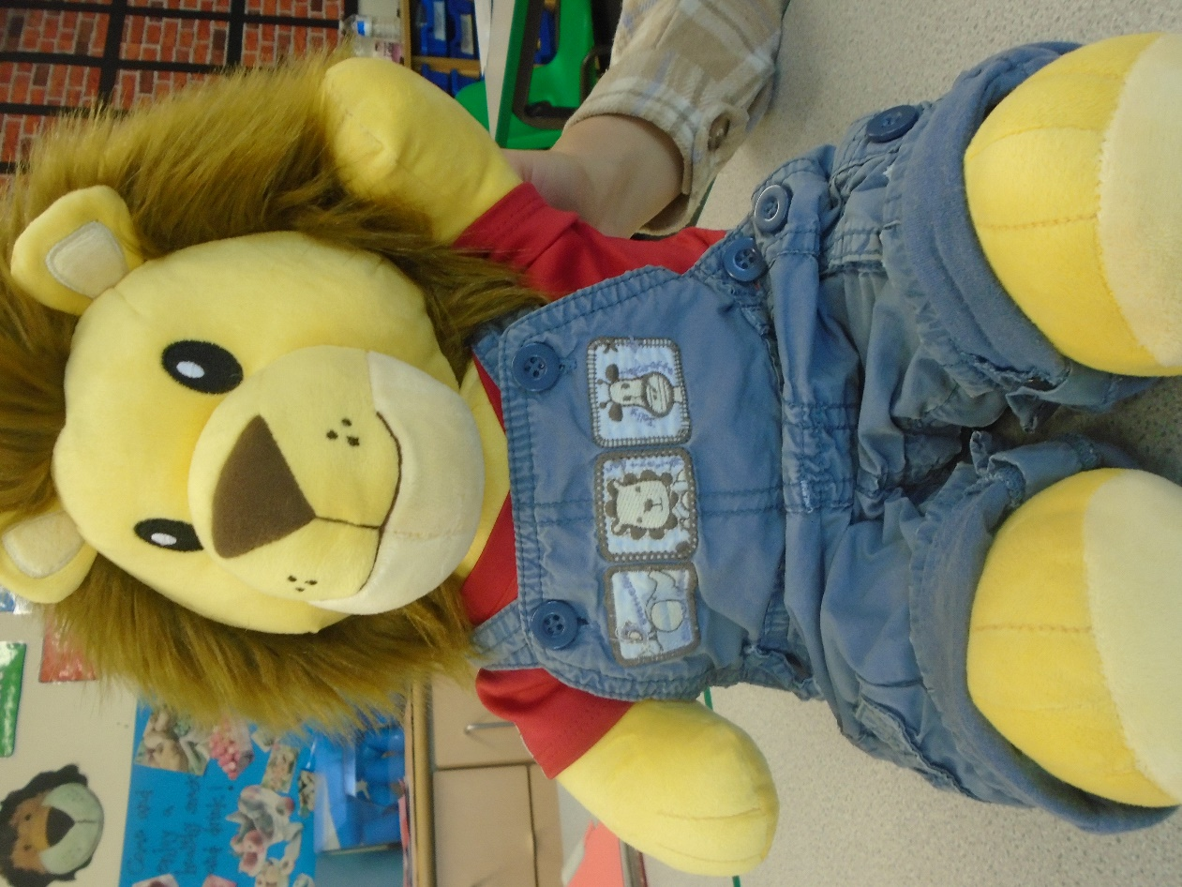

Ourselves
Lion class

A warm welcome to all our new children and parents! We are really looking forward to an exciting first half-term with all of you. I am Mrs Wheeler, the class teacher. Miss Maddox and Miss Dupe are the teaching assistants within the class who are here to support the children.

This half term the children will be thinking about themselves and each other. We hope that through this topic we will get to know all the children a little better.

Settling in
First and foremost we aim to settle your child into a routine which is both secure for them and also flexible enough to be exciting. The children will be learning to care for their own property and asking for help when needed.
They will also be getting to know the adults in the school and, more importantly, making new friends.
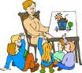
It is a time when they are expected to participate in much larger groups than they are probably used to. They will be learning to take turns and put their hands up to answer a question or be part of a class discussion. These things do not always come easily, but are always positively encouraged.

What the children will be learning
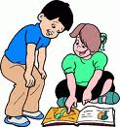
Communication and Language
- Listening attentively to adults and their peers
- Expressing their needs and emotions, asking for help
- Answering questions and talking about themselves
- Learning and using new vocabulary confidently
Literacy
- Development of early phonics, letter recognition and formation
- Development of reading skills and enjoyment of books through individual, group and whole class reading of stories, poems and non-fiction books
- Opportunities to practise emergent writing
- Name recognition and name writing

Mathematics
- Counting games and songs
- Counting out given amounts and labelling the amount
- Reading, writing, ordering and counting numbers 1 to 10
- Understanding the composition of numbers to 5 initially (number bonds)
- Development of mathematical language through play.

Understanding the World
The children will be thinking about their:
- family
- feelings
- home and school community

Expressive Arts and Design

The children will be using and developing their artistic skills to create their own:
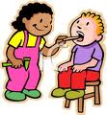
- Collage self- portraits
- Pictures of a family member using an iPad
- Photo frames to display a family photo
- Collage, painting and printing using a variety of media
- Exploring musical instruments
- Singing familiar and new songs

The children will be able to experience a number of different role play areas.

Personal, Social and Emotional Development
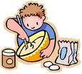
- Activities to encourage independence, concentration and confidence
- Developing strong relationships and managing emotions
- Create classroom values which the children follow and believe in
- Learning together skills (as part of our whole school Learning and
life skills approach)
- Learning about healthy eating and managing personal needs

Physical Development

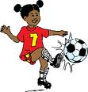
- Awareness of space during P.E sessions
- To use large and small play equipment
- Development of core strength, stability, balance, co-ordination and agility
- To develop fine and gross motor skills through play activities
- To hold a pencil to form recognisable letters

Your support

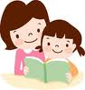
We hope you can assist your child in their learning by:

- Reading different types of texts with them regularly
- Reading their Monster Phonics books online
- Reading their focus and high frequency words
- Completing short learning journal tasks
- Reminding them to bring their reading book to school every day
- Ensuring they come to school wearing their P.E. kits on Tuesdays, Wednesdays and Fridays.

There will be some yellow stars in your child’s book bag soon. We want to celebrate what’s happening at home, as well as school. It could be something like moving up swimming groups or eating peas at dinner time without moaning! Please write down your child’s success and we will share, celebrate and display it.

Lions go to the library every Friday. Please make sure your child has their library book in their book bag each Friday, ready for a new one.

Important dates:

Autumn 2023 Half Term Break- Week beginning - Monday 23rd October

You will be getting an e-mail in the next couple of weeks regarding Tapestry, our online learning platform, which some of you will already be familiar with. You will then need to activate your account in order to view our observations of the children and perhaps posting your own observations/comments/home tasks! Tapestry can also be used to send messages to me.

Thank you for your support.

Mrs Wheeler and the Foundation team

“Lovely lions look, listen and learn. We can do it, we will do it, we will do it well!”

