Year 6 Gorillas Newsletter: April 2023

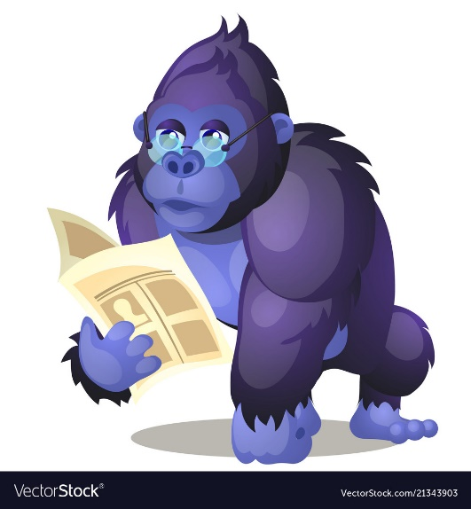I hope everybody had an extremely enjoyable Easter break. All pupils have returned to school with an excellent attitude to their work and learning; therefore, I would like to say a massive well done to the whole class.

We are now into our final term of the school year and, for your children, their final term at primary school. All of the children have worked incredibly hard this year and I am sure all members of the class will fulfil their potential and be more than ready for secondary school by the end of this academic year.

This term, we will be beginning our new topic, ID.

*Who do you think you are? Are you an extrovert or an introvert, a singleton, a twin or even a triplet? Let’s discover what makes you-you. From your fingerprints and footprints, to your genes and DNA, everything is unique to you. So why do you look like Mum or Dad, or even Auntie Rose? Explore the world of human identity and how our unique features can be used to tell us apart from others or help to solve a crime. Write reports, adverts and poems on the theme of identity and express your opinions, views and beliefs. Do you like the same things as others, or are your tastes uniquely yours? Then, it’s time for some detective work. In the case of the stolen handbag, use your knowledge and skills to solve the crime and identify the culprit. And remember to love being you. Why? Because there’s only one you. You’re one of a kind.*

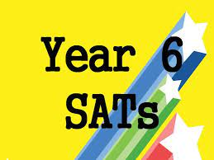On Tuesday 9th May, it is the beginning of this year’s SATs. All members of the class have worked incredibly hard throughout Year 6 to be ready for these. In preparation for SATs week, please ensure that your child has a calm, relaxed weekend beforehand. Furthermore, please ensure that your child arrives at school on time, each day.

In Maths, we will be completing the final units of the Year 6 curriculum and we will be revisiting previous learning to revise, consolidate and become more confident with all areas of maths. In English, we will be continuing to develop our independent writing, when writing narratives and across a range of non-fiction writing. In addition to this we will continue to develop our SPaG (spelling, punctuation and grammar) knowledge. We will also have weekly science and computing lessons. In science, we will continue learning about living things and their habitats; then, we will learn about evolution and inheritance.

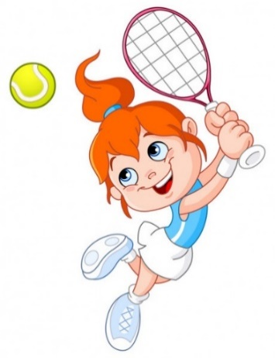

Our PE days will continue to be Monday, Thursday and Friday.

**PE kit should be worn to school on Mondays but a change of school uniform should be brought to school to change into after our PE lesson.**

**On Thursdays and Fridays, pupils should bring their PE kit to school in their PE bags.**

Finally, please remember to encourage your child to complete their homework to the best of their ability as this is good preparation for secondary school. If your child is unsure about how to complete a piece of homework, then encourage them to speak to an adult at school before it’s due in. Homework is due in on Tuesday, every week. Spellings should also be learnt, ready for our weekly spelling test.

**Dates for the Diary**

Monday 1st May: May Bank Holiday.

Monday 8th May: Bank holiday for the coronation of King Charles III.

Tuesday 9th May – Friday 12th May: Year 6 SATs week.

Friday 26th May: Break up for half term.

Tuesday 6th June: Pupils return to school.

I’m very much looking forward to our final term together.

Kind regards,

Mr Cunningham and the Year 6 team