Year 3 Monkeys

Autumn 2, 2024

Welcome back to another half term in Year 3!

It has been such a pleasure for me to observe how much the Monkeys have developed since the Lion class. I think they really enjoyed the busy 1st half-term, and certainly demonstrated what super learners they can be!

It was good to meet so many parents just before half-term to discuss your child’s progress at the parent’s evening sessions. Thank you for your continued support with homework, spellings and reading.

This term in English and Maths…

The children loved reading ‘Ottoline and the Yellow Cat’ last half-term and the work they produced was fantastic! This half-term our first focus will be Greek myths as part of our Ancient Greek topic. We will read and explore different stories and end the term by writing our own versions. I can’t wait to see their finished pieces!

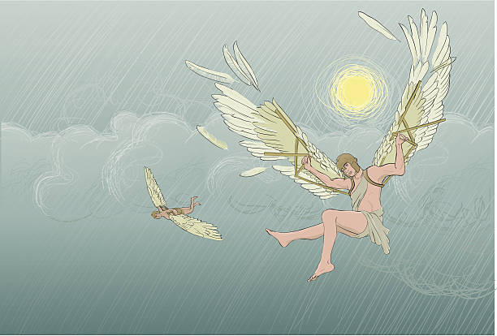

In Maths we will continue to use our Maths No-Problem resources and will start focusing on multiplication and division strategies. After this there will be a massive focus on our times tables so lots of practice at home would be wonderful.

This term in P.E.

Our P.E. days continue to be on Mondays, Thursdays and Fridays. The children will be learning gymnastics and netball. When the weather gets colder, it is important that the children wear joggers as some of the .PE lessons can take place outdoors. We would also like the children to use micropore tape on P.E. days to cover their earrings.

Homework….

The homework is handed out every Thursday and needs to be completed by the following Tuesday by the latest. Please let us know if your child finds it either too tricky or easy.

This term in Topic…

After some wonderful lessons in the first half term, the children will continue their quest to find out about life in Ancient Greece. We will be studying Greek influences on our modern world, which will include the alphabet, architecture, ancient Olympic games and theatre. In our art lessons, we will be designing and creating our own Greek pots.

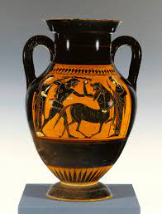 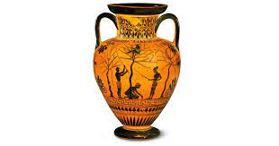 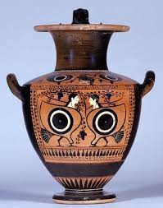 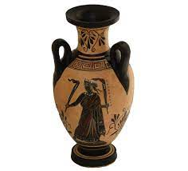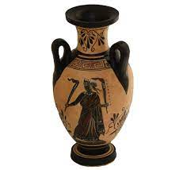

As ever, if you have any concerns or would like to discuss any issues arising within school then please arrange for an appointment or a phone call and I would be happy to help.

Kind regards,

Mrs Wheeler