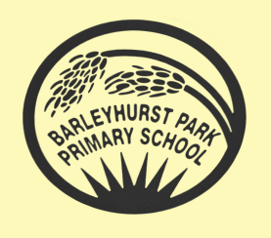

PANTHERS NEWSLETTER
November 2023
Our Learning
We have started English this half term by looking at narrative poetry and unpicking the strange and magical language of Lewis Carroll by looking in depth at his poem “Jabberwocky.” In the coming weeks, we will be undertaking an author study on former Children’s Laureate, Michael Morpurgo as well as improving our skills at non-fiction writing.
Maths will involve a mixture of multiplication, division and solving word problems. Remember to keep practising those times tables!
In Science we will move on to learn about humans, their life cycles and what they need in order to survive. In Computing we will be learning about a new program called Architects. The children will learn the basics of architecture and use shape, size and design to create their own house/building.
We will learn more about Ancient Egypt in Topic lessons, focussing on their belief systems, the discovery of Tutankhamun’s tomb (101 years ago this month), the building of the pyramids as well as the lives of ordinary people. Keep your eyes peeled for exciting news about our Egyptian themed trip in December!

We will continue to have PE on Mondays and Tuesdays so please do remind the children to bring their PE kits into school for those days. Remember that long hair should be tied up and earrings taken out or covered with micropore tape.

Welcome back to the second half of the autumn term. Although the clocks have gone back, leaves are falling off of trees and temperatures are dropping, the children have lost none of their enthusiasm for learning and returned eagerly to school to begin another packed and busy term.

Spellings should be practised every day if possible and the look, cover, write, check method should not be done in one go, but spread over the week so that the spellings are learnt with confidence and children are ready for the test each Friday.

Homework will continue to be set on a Thursday and should be handed in by the following Tuesday at the latest. Children should complete their homework to the best of their ability. If unsure about any of the homework set, pupils can speak to a member of the Year 5 team, before it is due in, for extra support and guidance.

Thank you for your continued support and communication. We are all so pleased with the effort the children put into their work in school and at home.
Mrs Blurton and the Year 5 team.

