GOrILLAS
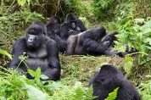
Newsletter: September 2023
Gorillas are gentle; gorillas are strong.

Welcome back
Welcome back to Barleyhurst Park for the final year of primary school; an important year, with lots of challenges and fun along the way. Mrs Smith has informed me that the children have had a very positive start to Year 6 after their summer break and I cannot wait to teach the class for the remainder of the academic year, having taught them on Move Up Morning and for some of their Year 5 swimming lessons. It should be an exciting first half term in Year 6: full of learning and hard work.

Year 6 is the final year in a pupil’s primary education: an opportunity to further enhance their learning and to prepare for secondary school. Pupils in Year 6 aspire to be excellent role models to the younger citizens of the school that look up to them; constantly demonstrating the school values for others to follow. They grasp the opportunity to show how responsible and mature they can be; leaving behind a legacy for others to follow. Year 6 is a year full of fantastic experiences and preparing for the next part of school life.

The Curriculum
English
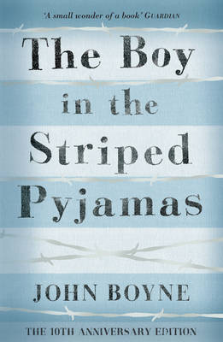
In English we will be studying ‘The Boy in the Striped Pyjamas’ by John Boyne. This will provide the stimulus for lots of our reading and writing work during English lessons. This is a wartime text so the children will find themselves learning more about their topic, A Child’s War, whilst developing their key reading and writing skills.

Maths
To start the year, we will be studying place value to 10,000,000 (10 million) which will include rounding numbers to any degree of accuracy. We will then be moving on to work based on the 4 operations (adding, subtracting, multiplying and dividing).

Topic
A siren sounds, a building crumbles, a Spitfire zooms overhead. Take cover. It’s 1939 and Britain is at war. Deep down in the Anderson shelter, learn why nations are fighting and why child evacuees must make the long journey from their homes and families into unknown territory.

Our topic for the term is ‘A Child’s War’ and is based on events from World War II. Through the study of this significant period, the children will develop their historical, geographical and social understanding.

Elsewhere across the curriculum, we will be learning about ‘Electricity’ in Science lessons. We will also have weekly Computing and Art lessons.

P.E. kit
P.E. lessons will take place every Monday, Thursday and Friday. Always having the correct kit for P.E. is a small way in which pupils can take responsibility. Pupils should come to school P.E. ready on a Monday and Friday. However, on a Thursday, pupils must ensure they bring their P.E. kit to school, in their P.E. bag. Friday’s P.E. lesson will normally be swimming (a separate communication will be sent regarding this) but pupils will still need their P.E. kits in school if they wish to do the P.E. option for Reward Time. On the weeks that there isn’t any swimming, all pupils will need their P.E. kit as we will have a P.E. lesson at school.

Homework diaries
Please ensure diaries are signed each week, as not only is this is good preparation for secondary school, but it also allows any communication between home and school to be picked up quickly and easily. Please encourage your child to hand their homework diary to a teacher if there is a message that needs to be read urgently.

Homework
As ever, homework will be given out on a Thursday and is to be returned to school by the following Tuesday, at the latest. Pupils should take responsibility for ensuring they complete as much of their homework as possible independently and handing it in on time.
Additionally, spellings will be set on a Tuesday ready for a spelling test the following Tuesday. Pupils should be learning these spellings at home alongside any other homework that has been set.

If you are in any doubt about the homework set, please speak to a member of the Year 6 team before it is due in.

Kind regards,
Mr Cunningham

