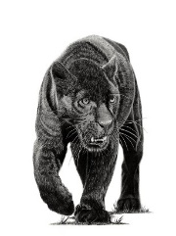**PANTHERS CLASS NEWSLETTER**

**June 2024**

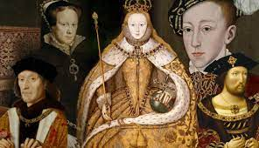

Hello everyone! It is so exciting to welcome the children back for their final half-term in year 5. All of the staff in Year 5 were so proud of the children for rising to the many challenges they were set in our Geography specialist week at the end of last term; we hope they enjoyed them as much as we did.

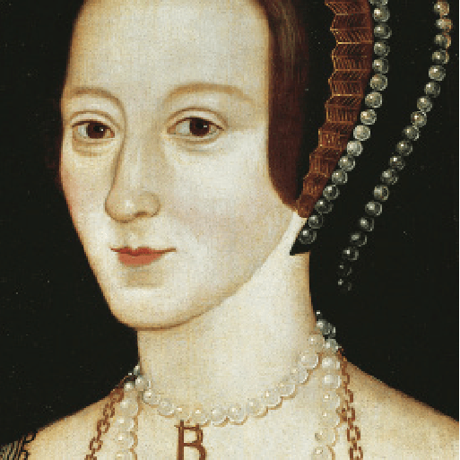

**Off with her head!** Our topic on the Terrifying Tudors continues. This term the children are focussing on the monarchs themselves and the changes they made to our country. They will also investigate famous battles, the beginnings of Empire and the role of pirates in the Elizabethan era. Not forgetting, of course, the spies, the music and the wives. Our class text is “Treason” by Berlie Doherty, a fantastic story of one Tudor boy’s battle to save his father. We are lucky enough to be chatting to Berlie later this term to ask her about the book and what inspired her to write it.

**English:** The children will be introduced to stories and poetries from other cultures from all over the world. As well as analysing the poetry, they will be reminded about figurative language and look at how it adds to the power of the poems. We will look at stories from across the globe, particularly from the modern era. Also, the children will be consolidating their basic writing skills in grammar and punctuation in preparation for their move up to year 6.

**Maths:** The term will start with area and perimeter followed by volume and Roman numerals. As the term goes on, the children will be working on securing their skills on place value, fractions and decimals, the four operations and answering word problems.

**Science:** This half-term, the children will be completing the topic of properties of materials looking at how to separate materials, reversible and irreversible changes the uses of materials and other properties like conductivity and solubility.

**Computing:** This half term the children will be exploring programming. This unit explores the concept of variables in programming through games in Scratch. First, learners find out what variables are and relate them to real-world examples of values that can be set and changed. Then they use variables to create a simulation of a scoreboard. They follow this by experimenting with variables in an existing project, then modify them, before they create their own project which they design and improve.

P.E. is still with the Sports Coach on Mondays when the children should bring their P.E. kit to school with them to change into. On Tuesdays and Fridays they should wear their P.E. kit to school. Swimming will continue to be on Friday mornings; please remind children to bring in their costume, a towel and goggles (if required) every Friday. Long hair must be tied up and earrings must be taken out or tape should be provided. No other jewellery should be worn. Water bottles are essential.

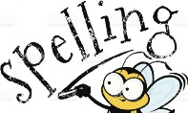Spellings will be given every Monday and there will be a test the following Monday. Please do look at the spellings as many times as possible.

Homework will also be handed out on Thursdays and then should be returned by the following Tuesday.

**Dates for your diary:**

Friday 14th June: Dress down day for the start of the Euros

Tuesday 18th June: Henry Allen’s Superhero day

Friday 28th June: Dress down day and bring a bottle for the Summer Fayre tombola

Wednesday 3rd July: Summer Fayre

Friday 19th July: End of term

Once again, thank you for your continued support.

Mrs Blurton and the Year 5 team