Barleyhurst Park Primary School
Year 3 Monkeys
Autumn Newsletter 2023
‘We try our best, we swing to success.’

Welcome Back!
Welcome back and welcome to a new school year. I would like to take this opportunity to introduce myself as the Year 3 teacher. My name is Mrs Burns and I have taught at Barleyhurst for many years now! We are also very lucky to have Mrs Way as our teaching assistant.

I hope that the children have had a fun and restful summer holiday and that they are ready for an exciting first term of learning with us!

Topic

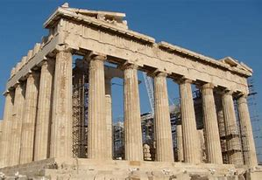

Our first topic will take us back in time to Ancient Greece!
We will learn about the landscapes, climates, people and the gods who were such an important part of everyday life in Greek times. Pupils will use their research to produce fact files packed full of interesting information and to create their very own ancient Greek pottery. In our first week back we will be taking part in a Greek day where the children will be eating Greek food, listening to Greek music and some traditional dancing!

English and Maths

Our first lessons in English will be a consolidation of the sentence level work that the children completed within their time in Year 2. Our first book study will then commence, and I know the children will love the story! We will be reading ‘Ottoline and the Yellow Cat’ and focusing on the genre of mystery stories. At the end of the unit, the children will have the opportunity to write their own mystery story.

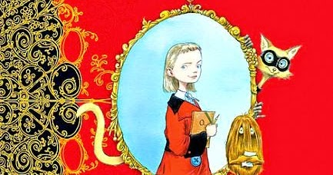

In Maths, we will begin the year with a heavy focus on numbers up to 1,000 and how we can compare, order and partition them.

During our Science lessons the children will be learning about Healthy Eating and an active lifestyle. This will be supported by our PE sessions, which will take place on Thursdays and Fridays. For these sessions, your child will need to come into school in a full PE kit of shorts, t-shirt and suitable outdoor footwear. As the weather gets colder, they may also need a sweatshirt or tracksuit. We also ask that all pupils with earrings bring in micro pore tape to cover their jewellery as we do not have any in school.

Forest School sessions will take place in Year 3 and this is such an exciting opportunity for our class. The session will be on a Wednesday and will be outside…rain or shine! On Wednesdays the children will need to come into school in a PE kit but they will need to wear jogging bottoms as lots of the work will involve being in the outdoor environment. A change of shoes is also advisable as the weather changes. Wellies would be ideal!

Pupils will be set English and Maths homework on Thursdays. Spellings will also be set each week and a test will be held on Fridays. We would appreciate it if you could continue to fill in the reading log every time you hear your child read this year. I love to reward the children who make the effort to read at home.

We are always happy to discuss any issues that may arise during the term which you feel we need to be made aware of. The happiness of all the children in our care is of utmost importance. If you need to speak to me I will be at the gate most mornings and at the door at the end of most days but alternatively please phone the school office to speak to me and I will call back as soon as possible.

I hope this newsletter gives you some insight into what we will be doing this term. I am very excited about the year and can’t wait to get started.

Kind regards,
Mrs Burns

