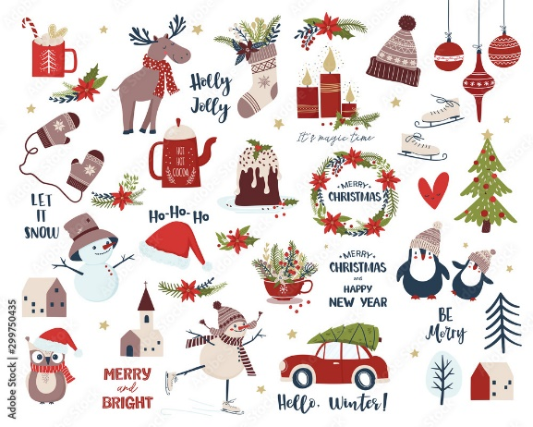

“Lovely Lions look, listen and learn. We can do it, we
will do it and we will do it well.”

Welcome back lovely Lions! The whole Foundation team have been really impressed by how well the children have settled into their new school and class. They are already so much more confident and more than ready to start this term’s learning. The children loved the Book week just before half-term. I hope it was an unforgettable experience and I am sure there will be many more exciting things to look forward to this half-term!
Our topic this half term is ‘Celebrations.’ We will be learning about celebrations that are familiar to lots of children such as Bonfire Night, birthdays, and Christmas. We will also be learning about festivals that may not be as familiar to all the children such as Diwali and Eid. During this half term we will also be looking at how our environment is changing during the autumn season.
School life
We will continue to help the children feel settled in the school environment and reinforce the expectations we have of them.
The children will continue to put away their belongings, find their name, listen and follow instructions.
Throughout the day, the children will have opportunities to choose activities that are both indoors and out. They will be expected to complete different activities with myself or the other adults in the class, but will also continue to choose independently.
The children are now starting to join some of the school assemblies, such as our Star of the Week assembly on Fridays and are enjoying being on the playground at playtimes, too.
As you may have noticed the children now have the opportunity to choose a book from the school library each week. They need to return the book the following Friday in order to borrow a new Library book.
The children will be joining Year 1 and Year 2 as we begin to learn songs for our Christmas play.
What the children will be learning
Communication, Language and Literacy
- Continue the development of letter recognition and formation.
- Development of reading skills and enjoyment of books.
- Sequencing and retelling events in stories using ‘Talk for Writing’
- Opportunities to practise emergent writing.
- Name recognition and name writing.
- Learning new letter sounds every week in Monster Phonics lessons.
- Learning focus words and high frequency words in Monster Phonics.

Mathematical development
- Counting games and songs.
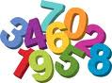
- Reading, writing, ordering and counting numbers 1 to 20.
- Recognising different 2-D shapes in our school environment.
- Exploring composition of numbers to 5
- Create our own repeating pattern.
- Thinking about the number that is one more.

Understanding of the world
- Thinking about different celebrations such as Bonfire Night, birthdays, Christmas, Diwali and Eid.
- Using simple IT equipment.
- Looking at our environment and thinking about the seasonal changes.
- Learning about hedgehogs and hibernation.
Expressive arts and design
- Create firework pictures using different painting techniques.
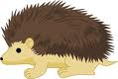
- Make clay hedgehogs, using clay tools.
- Make colourful Rangoli patterns.
- Make food for Leo the Lion’s birthday party.
- Different role play experiences.
- Exploring instruments and listening to music from different cultures.

Personal, social and emotional development
- Activities to encourage independence, concentration and confidence.
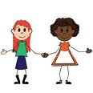
- Continuing to be thinking about our classroom values.
- Thinking about our own community.
- Forming relationships within our classroom.

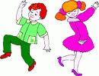
Physical development
- Developing an awareness of space.
- Using large play equipment safely.
- Travelling, using different parts of the body.
- Learning basic gymnastic shapes, balances and jumps.
- Improving their general fitness.
- Learning to express themselves through dance.

Your support
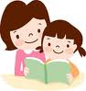
We hope you can assist your child in their learning by:
- Sharing the weekly Monster Phonics e-books as indicated in the weekly sticker in their reading record.
- Writing a brief comment in their reading record.
- Helping them to learn their focus and high frequency words as indicated in each e-book.
- Reminding them to bring their reading record to school every day.
- Keeping informed about weekly learning by logging onto Tapestry and completing a fun learning task at home.
- Ensuring all items of clothing are named.
- Ensuring that they come to school wearing the correct P.E kit on Tuesdays, Wednesdays and Fridays.
- Useful websites: www.topmarks.co.uk, (early years section) www.bbc.co.uk/cbeebies , www.phonicsplay.co.uk (phase 1 and 2 games), www.iboard.co.uk (4-7 years).

Thank you for your continued support.
Mrs Wheeler and the Foundation team

