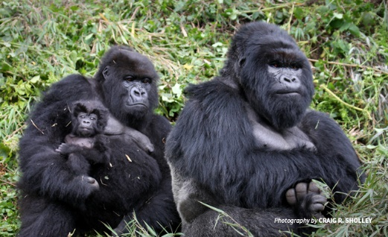
GORILLAS

Newsletter: January 2023

Welcome back & thank you
Firstly, I’d like to begin by taking this opportunity to wish you all a Happy New Year. I do hope that you and your family managed to have an enjoyable Christmas break. I would also like to thank you for the very kind gifts the Year 6 team received prior to the end of term.
After a fun-filled final week of the autumn term and a much needed end of term break, it is great to see all the children refreshed and ready for another exciting term.

The Curriculum
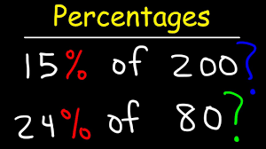
Maths
We will start the spring term by beginning our study of percentages. Once we have finished learning about percentages, we will then move on to ratio and algebra.

English
In English, we will be using our new topic as a stimulus for our learning as well as focusing on our independent writing targets.

A Child’s War
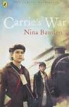
With a new term beginning it means the end of our fantastic World War II based topic. Throughout the autumn term all the children in Year 6 learnt lots of interesting facts and produced some fantastic work. My personal highlight was reading and discussing both of our class texts which were linked to our topic.

Frozen Kingdom
Take shelter from the elements or fall prey to icy winds and the deepest chill. Trek bravely and valiantly across treacherous terrain to the ends of the Earth, treading deep in snow or be pulled by a team of mighty sled dogs. Be alert, for magnificent mammals roam these lands, sometimes hungry or fresh for a fight. Perhaps a hungry polar bear or an Arctic fox is hunting rodents, as swift as the wind!
For the spring term, our topic is based on the planet’s coldest lands. Throughout the topic, pupils will have the opportunity to develop their knowledge of different polar regions from around the world.

As ever, we will also have weekly Science, Art and Computing lessons.

Taking responsibility
There are a number of things that Year 6 pupils can do to ensure they are taking responsibility, which in turn will help prepare them better for secondary school. Firstly, ensuring that book bags come into school every day with the correct books (home school record books and spelling record books). They can also make sure that they have the correct uniform for each day, bring their water bottle and hand in their homework on time.

PE kit should be worn to school on Monday, pupils should bring their uniform to school to change into after PE.

PE kit should be brought to school in a PE bag on the following days: Thursday and Friday.

Homework diaries
Please ensure diaries (home school records) are signed each week, as not only is this is good preparation for secondary school, but it also allows any communication between home and school to be picked up quickly and easily. Please encourage your child to hand their homework diary to a teacher if there is a message that needs to be read urgently.

Homework
As ever, homework will be given out on a Thursday and is to be returned to school by the following Tuesday at the latest. Pupils should take responsibility for ensuring they complete as much of their homework as possible independently and handing it in on time.

Furthermore, spellings will be set on a Monday ready for a spelling test the following Monday. Pupils should be learning these spellings at home in addition to the homework that has been set.

If you are in any doubt about the homework set, please speak to a member of the Year 6 team before it is due in.

Kind regards,
Mr Cunningham & the Year 6 Team

