Barleyhurst Park Primary School

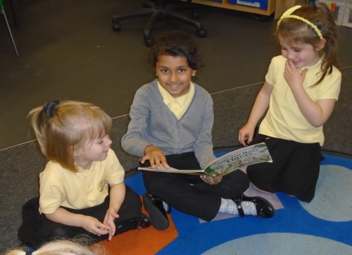
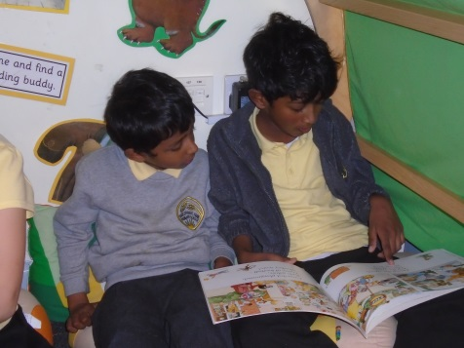

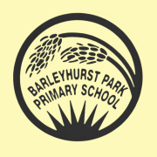

Early Years
Foundation stage
Reading
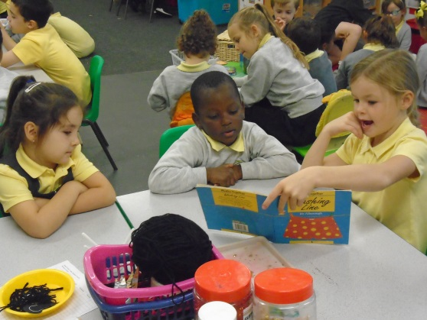
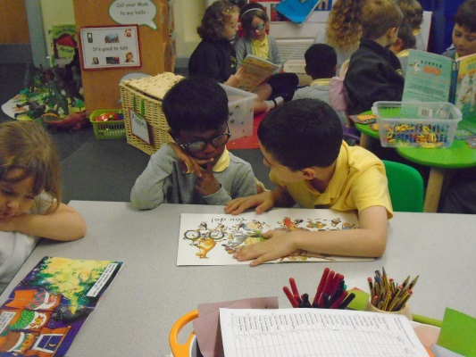

The power of reading

Creating a love of reading in children is one of the most powerful ways of improving academic standards in school and at home. A reading family is learning and thinking family.
There can be few better ways to improve children's chances in school or beyond in the wider world than to enable them to become truly independent readers. Reading is all about acquiring meaning i.e. for enjoyment, information and understanding. It’s not a test– every time you finish a book, do you always choose a harder one next time?

Reading at home—Enjoy

Reading is taught and practiced at school. Home is also a great place to practise but in a more informal and relaxed atmosphere. If possible share books every day. Introduce your child to different types of books; fiction, short stories, joke books, poetry and non-fiction. When reading, read slowly and with expression. Try to use different funny voices for characters! Follow the words with your finger and read the story using the pictures to help understanding. Talk about what is happening and what might happen next. You might want to leave stories on a cliff hanger.

What is Phonics?

A phonics approach focuses on learning to associate printed letters with their corresponding sounds. Phonics instruction gives children strategies to unlock or decode words.
We use a systematic phonics programme with the children – Letters and Sounds.
Through their phonics work children will learn to:
- match letters to the sounds they make – graphemes to phonemes
- apply the sound knowledge to reading and writing words
- learn spellings with phonic patterns
- practise blending letters to make words
- practise selecting graphemes (letters) to spell words
- learn letter names
- continually practise recognising, reading, word building and letter formation with new sounds.

Focus on the sounds the letters make

sh o p = shop
l ou d = loud
c l ow n = clown
Children begin by learning single sounds and then progress to using digraphs and trigraphs.

Not all words are phonically decodable, hence ‘tricky/key words’.

Segmenting and Blending Sounds

The words that your child speaks and reads are made up of separate
Sounds (phonemes). Your child will learn these sounds in Foundation and
key stage one. Your child will learn to blend the separate sounds together to read a word. This is what your child will call Segmenting and blending. You can help your child to blend sounds by making sure that they recognise the sound that the letter/s make and say the sound correctly. Play oral blending games at home and when out and about. Please could you bring me the C u p. Let’s go to the sh o p s’. Use phoneme fingers– say each sound crisply and point to the tip of each finger / thumb first. Fold down unused fingers. Run your finger across the tips and blend the sounds to read the word.

What do we do when we read?

Blend the letter sounds together to read to read the word.

Make connections with what we already know. Bringing in our exciting knowledge,
understanding and personal responses to a new texts.

Consider whether we like or dislike the text or whether we think it is a good read.

Understand the text. Know what the individual words and the whole text means.

Make a personal response. How does text make you feel?

Engage with the text. ‘See’ the pictures the words make.

When phonics are not enough

Sometimes ‘sounding’ out’ is not enough. Some words don't fit the rules so other Strategies are needed. If your child cannot read a word suggest that they miss it out and read to the end of the sentence. What word would make sense?
What sound does it begin with? Does it sound right? Does it look a bit like other words you know? What word would make sense in this story or subject? Does the picture give you a clue?

Understanding, connecting, engaging and responding to texts

Being able to read the words, does not necessarily mean that your child understands what they have read. Your child might sound like a fluent reader which can make you believe that they are a ‘good’ reader. The only way to judge how much your child understands is to talk about the book and ask questions that make him/her think.

• What do you think this book will be about?
• I wonder what will happen next. What do you think?
• Does this remind you of anything/a place that you have been to/a feeling?
• What is happening here?
• How do you think this character feels?
• What do you think s/he should do?
• Why do you think the character has done/said that?
• Does this remind you of any other stories that you have read?
• What were the main events in this story?
• What happened at the beginning, middle, in the end?
• What does this word mean? How can we find out?
• Do you like these words? Why? How do they make you feel?
• Did you like the story/book? Why? Why not?
• Which words would you use to describe this character?
• Do you think this character is good or bad? Why?
• What was the best bit?
• Is it a story book or a fact book?

Helpful Hints
- Make sure the atmosphere is calm and relaxed so your child enjoys the time together.
- Let them sit with you and keep the session short. Read as often as you can; try to read every day, establishing a routine will help.
- Give plenty of praise.
- Let your child read at their own pace, encouraging them to make attempts or ‘sound out’ words they don’t know.
- Tell them the beginning sound if they don’t know it but if this still doesn’t help just tell them the word and move on swiftly, try not to make an issue of it.
- Look at and discuss the pictures, they’re not cheating by using them for clues.
- Always ask your child’s teacher for help and advice with reading at any time.
- Don’t allow your child to feel they are in competition with anyone or that they should try to ‘get through’ the colour bands quickly.
- Turn the television off!
- It is so important that your child understands what they are reading and enjoys the humour or the moral of the story.
- You are the people who have time to sit comfortably and make reading so much fun for your children.
- It is perfectly fine if your child reselects the same book on several occasions – we all have our old favourites!
- While your child is practising at home we will be busily teaching them to read through daily phonic sessions (letters and Sounds), whole class reading; exploring the range of reading strategies.
- Respect choices, your child is much more likely to become a reader if they are interested in what they are reading. Comics and special interest magazines are allowed.

Our reading scheme
In Foundation Stage phonics is taught using Monster Phonics. Its used as the main tool to enable our children to learn to read and write. Monster Phonics has been validated by the department for Education. Please find more details on our Monster Phonics section on the school website.
Inside your child’s book bag
Reading diary
This is for home and school to record when your child has read individually and also to comment on their reading. We welcome positive comments about their reading, but some parents have said they are never sure what to write. If there are particular phonic patterns that children find difficult it is also appropriate to comment. We encourage lots of talk about a text which reflects comprehension. It is great to have your feedback about this. These will be checked twice a week to ensure children are reading at home. Reading records must be signed in order for your child to change their reading book.

Reading books
To begin with, most children will have a book which contains few words. These types of book are valuable at this early stage of reading. Using pictures to tell a story is one of the first reading strategies children will develop. We expect parents to share the book with their child up to three times a week, looking at pictures and discussing what the child can see. This should take about 5 – 10 minutes. The children will be issued with a school library book which will be changed on a weekly basis.

Parents will receive log in details on how to access their Monster Phonics reading book at home. Currently children do not take a reading book home but access the text online.

Name books

The children have a name book to practise writing their names at home. Initially we teach the children to write their first name and then their surname. If your child can already write their first name please help them to form the letters correctly. Children are expected to write their name using lower case letters and just a capital for the initial letter. This book will not be marked and is for home use.

Thank you

We are grateful for the valuable support you provide through practising reading with your child at home. We know that you all wish to encourage your children to progress well with their reading and become both competent and enthusiastic readers.

Mrs Wolfe

