Barleyhurst Park Primary School
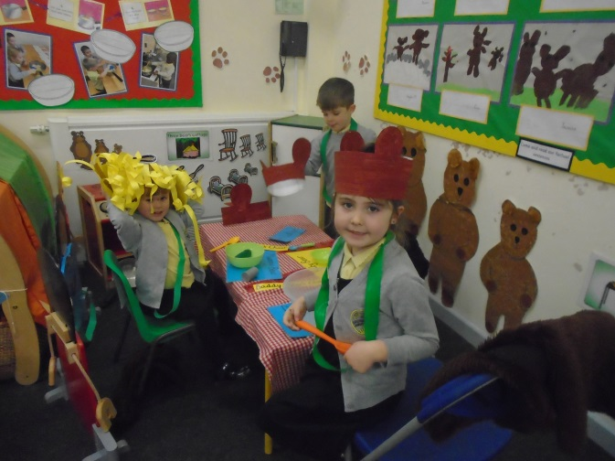

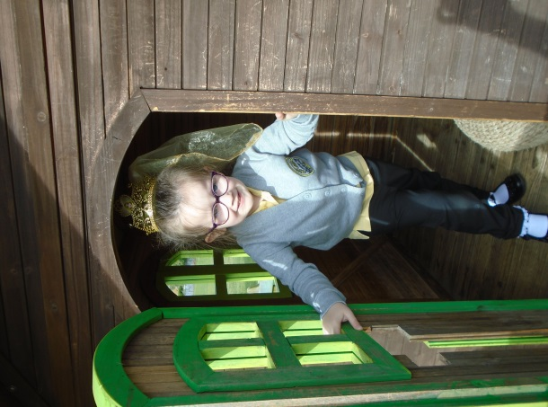
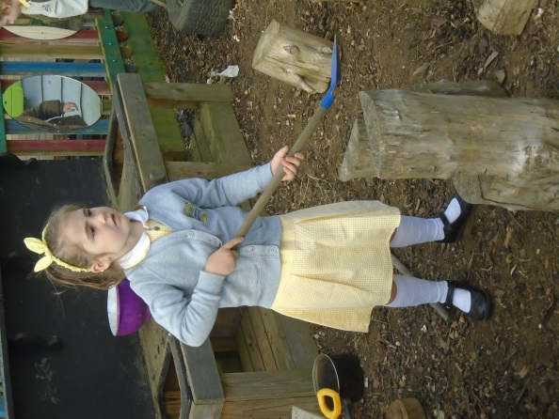
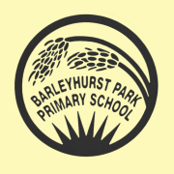

Early Years
Foundation stage
Welcome pack for parents

Welcome message from the Head teacher

We are so pleased that you will be joining our school in September. I really hope you and your child are excited to join our school community.

Our school provides a positive learning environment, and we are extremely fortunate to be able to offer high quality facilities and resources. Central to our vision and value is the desire to ‘unlock the potential’ within every pupil.

We are determined to provide a rich and varied learning environment. We recognise that a positive partnership between home and school enables us to work together to ensure the pupils make good progress both academically and socially and that they are safe and happy.

I hope you find the information in this booklet useful. If you have any further questions please do not hesitate to contact the school office.

I look forward to welcoming you in September!
Thank you for your understanding. Kind regards

Mrs W Smith

Our induction process-for parents and carers

This very unique time has meant we have had to make many adjustments to ensure we follow the guidance set out by the government. We will hopefully be able to hold our evening induction meeting this year. Dates will follow. We hope this booklet answers all your questions and gives an insight into how the children learn and play at Barleyhurst Park Primary school.

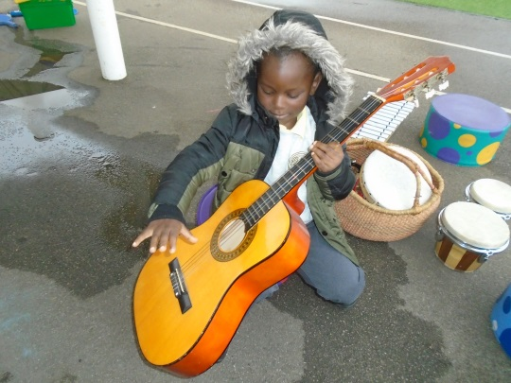
You will find all the important pieces of information in this induction booklet to ensure a smooth start to school.

Visits to setting

We contact each early years setting to take verbal reports regarding your child. This enables us to get to know the children by talking to setting staff who already know your child really well. If necessary, we will make a visit to that setting.

Home visits

We are offering home visits for all parents/Carers before September. This is an opportunity for parents/Carers to have a private 1 to 1 conversation regarding their child if they feel it is necessary. Please contact school to discuss a date with the Foundation stage team.

All dates to be confirmed

As we reach Summer, hopefully you and your child will be excited about starting school. Our induction process will start in June and we will hold grouped play sessions for all the children. This will hopefully be less daunting for the children as there are fewer children and it gives us a much higher staff children ratio, so staff can spend much more time building relationships with all of the children and supporting them all as they start school life. You will receive a separate invitation to these sessions. We will also be inviting you to a whole group teddy bear’s picnic

The Early Years Foundation Stage curriculum
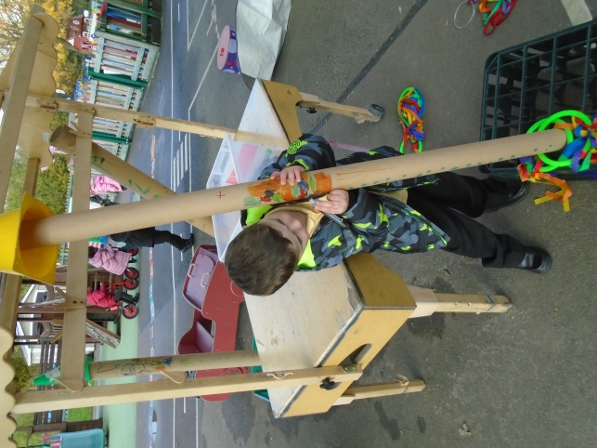
The Early Years Foundation Stage (EYFS) sets the standards for learning, development and care for children from birth to five.

The statutory framework for the Early Years Foundation Stage contains the legal requirements and statutory guidance which we follow.

There are four over-arching principles for the EYFS. These are:

- Every child is a unique child
- Every child is a competent learner from birth who can be resilient, capable, confident and self-assured.
- Children can learn to be strong and independent through positive relationships.
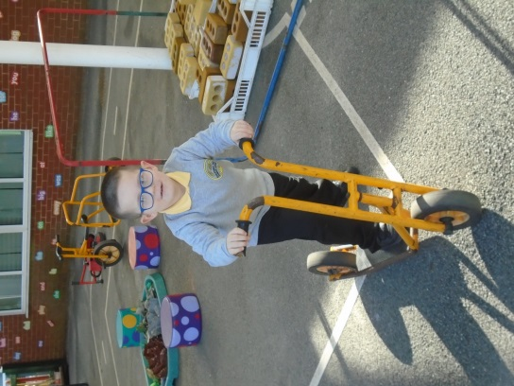
- Children learn and develop well in enabling environments in which their experience respond to their individual needs and there is a strong partnership between practitioners and parents or carers.

Children develop and learn in different ways and at different rates. The framework covers the education and care of all children in the early years including children with special educational needs and disabilities.

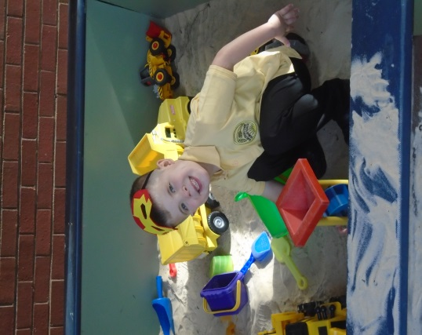
Learning and development

There are seven areas of learning and development.

All areas are important and interconnected.

The prime areas are

- Communication and Language- Encouraging talking and listening
- Physical development - Physical control, mobility, awareness of space and manipulative skills in indoor and outdoor environments. Establishing positive attitudes towards a healthy and active way of life.
- Personal, social and emotional development- Learning how to work and play, co-operate and function in a group, develop personal and moral values, understand themselves and others.

The children are also supported in four specific areas, through which the prime areas are strengthened and applied.

These specific areas are:

- Literacy- encouraging children to be confident and independent readers and writers.
- Mathematics- Mathematical understanding and the foundations of Numeracy, with a focus on practical maths.
- Understanding of the world - Finding out about the world around them, other people. These become a foundation for History, Geography, Technology and Science
- Expressive arts and design- The development of imagination and the ability to communicate and to express ideas and feelings in creative ways.

The Early Years team consider the individual needs, interests and stage of development of each child in their care and they use this information to plan a challenging and enjoyable experience for each child in all areas of learning and development.
Leading learning in EYFS

At the end of the year an EYFS profile is completed for each child. Each child is assessed in relation to the 17 Early Learning Goal (ELG) descriptors.
The early years setting at Barleyhurst has a self-contained, well planned outdoor area with spaces for sand play, water play, digging, running, writing, reading and play. The children have access for free-flow between the outdoor and indoor areas.
Play underpins the delivery of all the EYFS. Young children learn most effectively through structured play. We plan to ensure all seven areas of development are covered in an interesting, stimulating and supportive framework. We make sure the children progressively develop their skills and knowledge throughout this phase of their school life. The children are taught directly and also have a choice of planned activities so that they are able to develop independent learning habits. We actively encourage them to initiate their own activities.
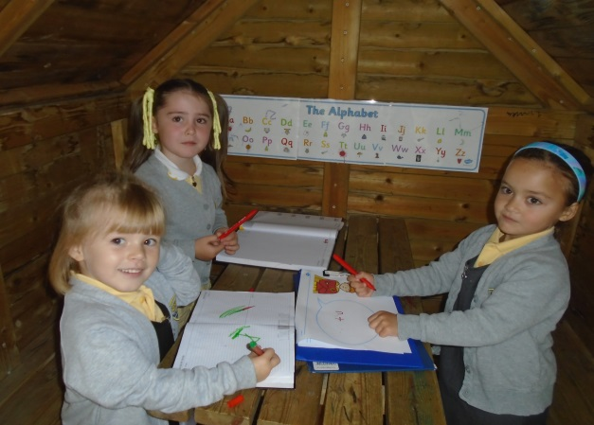
We are very lucky to have a large indoor and outdoor area for them to use and explore.
Indoors
- Reading area
- Role play area
- Small world
- Construction area
- Writing table
- Fine and gross motor
- Puzzle table
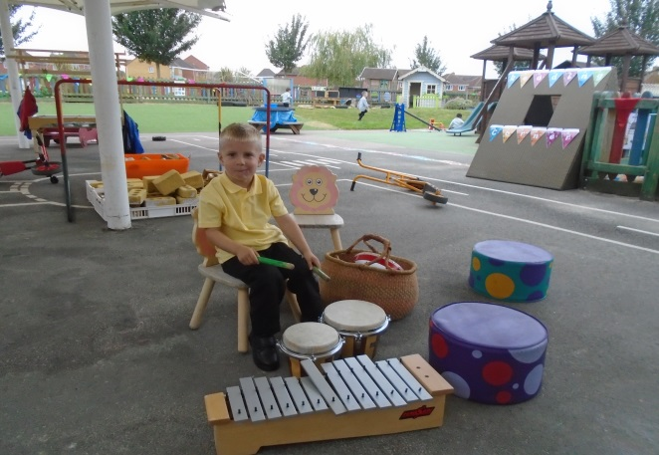
- Art table/messy play
- Computer/Ipad

Outdoors
- Bikes and scooters
- Climbing equipment
- Play houses
- Writing hut
- Reading tent
- Mud kitchen
- Wildlife area
- Grassed area – football net
- Sandpit
Home- school partnership

At Barleyhurst we like to foster strong links between home and school from the very start. This has a positive impact on children’s development and learning. A successful partnership needs a two-way flow of information. This is often done informally on a day to day basis before and after school, as well as through Tapestry (an online learning journal) and more formal consultations.

Tapestry is an easy to use online learning journal, Tapestry helps our school and parents to record, track and celebrate children’s progress and development. Text, images and videos can be easily viewed via PC, tablet or mobile app- anywhere there’s an online connection. Every entry helps create a complete story of a child’s time in EYFS at Barleyhurst.

Tapestry is like a window into your child’s EYFS learning where experiences are captured and shared with you. You can also share your child’s home learning by uploading it into their tapestry account.
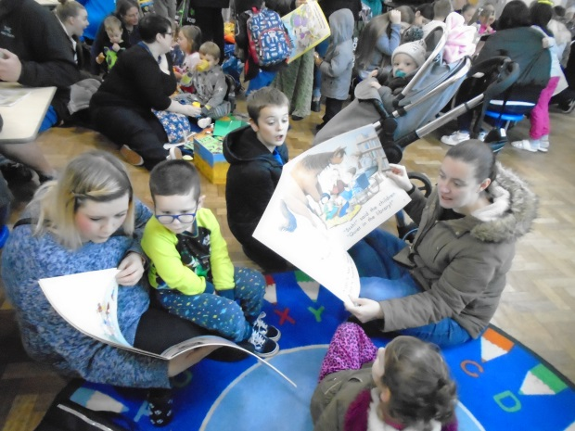
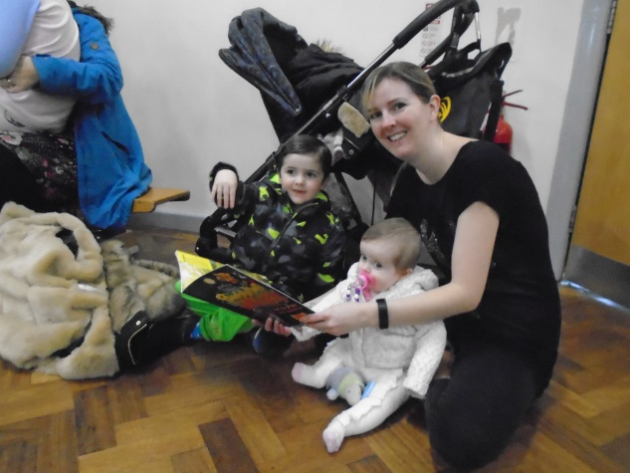

A day at Barleyhurst Park

School begins at 8.40am
On your child's first day, please bring your child to the school’s
Main gates.
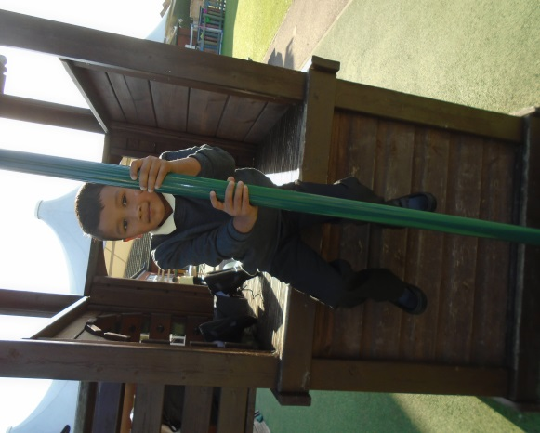
Registration closes at 8.50am

(A typical day)

8.40 -9.00 Greet, early work and registration

9.00 -10.00 Morning lessons/activities

10.00 – 10.15 Assembly

10.15 – 10.30 Playtime
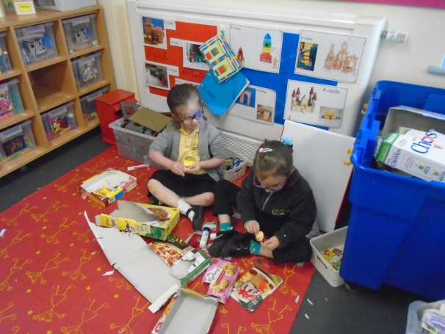
10.30 -11.45 Phonics lessons/activities

11.45 -12.45 Lunchtime

12.45 – 2.00 Afternoon lessons/activities

2.00 - 2.15 Playtime

2.15 - 2.30 Tidy up time

2.45 -3.15 Story time / getting ready for home time.

Unfortunately, some of these timings may be slightly different in September due to the need for staggered starts, breaks and end times for each bubble. We will ensure that we confirm timings in September.

We split the year into six different topics, which cover the 17 Early Learning Goal (ELG) descriptors.

Autumn Term
1st half ~ All about Me
2nd half ~ Celebrations
Spring Term
1st half- Bears
2nd half- Buildings
Summer Term
1st half-Transport
2nd half-Mini beasts

Trips and events

We aim to provide our children with a wide range of experiences and opportunities. We organise school trips and have WOW experiences at the start of each new topic to help promote an excitement for learning.
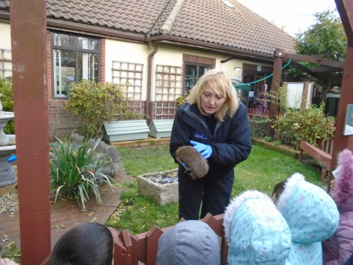
Autumn term

- Visit to Tiggywinkles animal hospital as part of our autumn topic
- Harvest festival celebration with parents
- Whole school specialist book week. Children are encouraged to dress up as part of a given theme
- Nativity play
- Christmas jumper and dinner day
- Christmas party day…with a special visitor

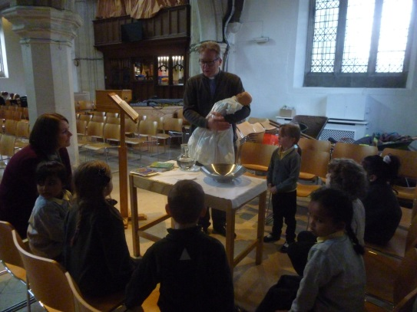
Spring term

- Visit local shops as part of our building topic
- Visit St Mary’s church as part of our building topic
- Chinese New Year celebration
- Mother’s day celebration afternoon tea
- Mother’s day celebration assembly
- Whole school specialist week
- Easter egg hunt

Summer term

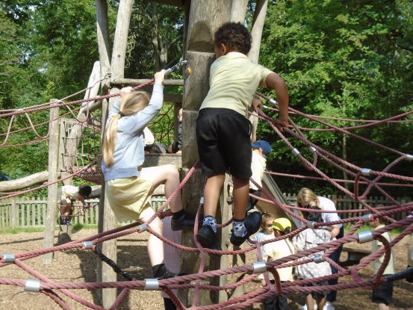
- Visit to Pirate golf at Abbey Hill as part of our transport topic.
- Father’s day celebration assembly
- Whole school specialist week
- Visit to Salcey Forest as part our Mini beasts topic
- Zoo lab visit to our school as part of our Mini beasts topic

Reading together

The last Friday of every month Mums, Dads, Grannys or Grandads can come into our classroom for 15 minutes and share a book with their child.

What to expect daily, weekly and monthly

- Morning snack- Children can either have milk or water and a piece of fruit
- After the children have eaten their lunch (hopefully in the hall), they will go back to the classroom to continue their lunchtime play for the first couple of weeks.
- Morning play- just Lions and afternoon play with year 1 and 2 children once it is safe to do so. Initially in September each year group will have their own playtime slot, as class bubbles will need to be kept separate.
- Year three buddies- when it is safe to do so children will be introduced to a child in Year 3 who will be their ‘buddy’ when the children begin to join the whole school at playtimes and lunchtimes.
- Children will start with Friday Celebration assemblies and hopefully after the half term break join the daily assemblies. Assemblies will initially be virtual, as large gatherings may not be permitted.
- Two P.E sessions a week. One with sports coach.
- Once it is safe for other people to come into school, the last Friday of the month Parents and Carers can come into our ‘Reading Together’ sessions.

The first few weeks

During the first couple of weeks we will be settling the children into their new learning environment. We will be focusing on sitting on the carpet for short periods of time, putting hands up to participate, focused and self-led learning activities, playtimes and lunchtimes.
We will find out what the children already know and can do (on entry assessment) and use this information to support our planning.
You will be invited to discuss how your child has settled in and their progress so far at a Parents’ Evening in October.

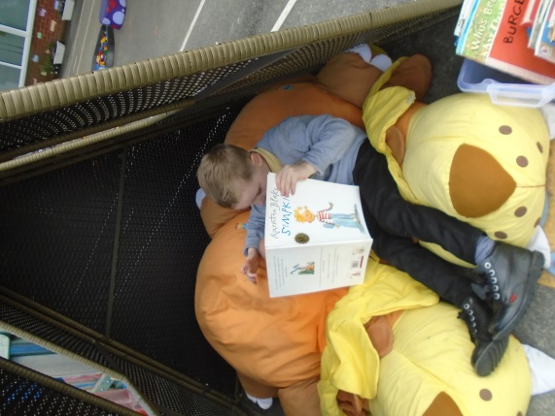
Reading information meeting

Just before the first half term we hope be inviting parents and carers to a meeting to explain how we teach phonics and reading as a school. We understand that you have expectations of us as a school and we also have expectations of our parents to be part of this exciting learning journey. If this is not possible we will ensure that this information is shared with you in an appropriate manner.

Food

All the children are entitled to a universal infant free school meal. Our catering company, EB’s Catering supplies both hot and cold choices. You will receive additional information about this. Alternatively you can supply a lunchbox for your child from home. No fizzy drinks or sweets please. The children are offered a fruit snack and milk/water during the morning break time. The children are encouraged to have water throughout the day.

Medical Matters

- Any sickness, diarrhoea, must be followed by 48 hours absence.
- Any absence requires a note or telephone call explaining why.
- Head lice are common! Please check regularly and treat as recommended.
- Any medicines can only be administered by school if prescribed by a doctor and is required four times a day.

Thank you

Thank you for taking the time to read this booklet. This is not the way we usually deliver our information but I’m sure you understand. Please do not hesitate to contact us. We know this is a very unique time but our upmost wish is that your child and their induction is as unaffected as possible. In September your child will be in Lion class (each class takes on an animal and what is symbolizes). We start every day with this chant, which we believe is as important as ever.

Lovely lions look, listen and learn
We can DO it
We will DO it
WE WILL DO IT WELL!

For more information please visit our website
Barleyhurstpark.com
Contact us
office@barleyhurstpark.com
01908 378291
Forfar Drive
Bletchley
Mitlon Keynes
MK3 7NA
