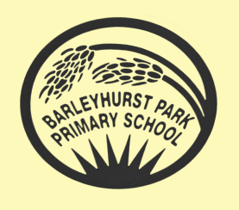
PANTHERS CLASS NEWSLETTER
April 2023

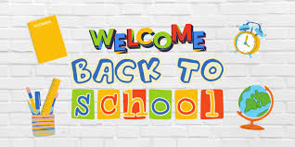

Welcome back Year 5! Thankfully, the days are beginning to get longer and sunnier as we enter summer term, 2023. This term is full of excitement, fun and drama; we have lots to look forward to. Year 5 staff are very proud of how hard the children worked last term and how much they are using their learning to help them progress.

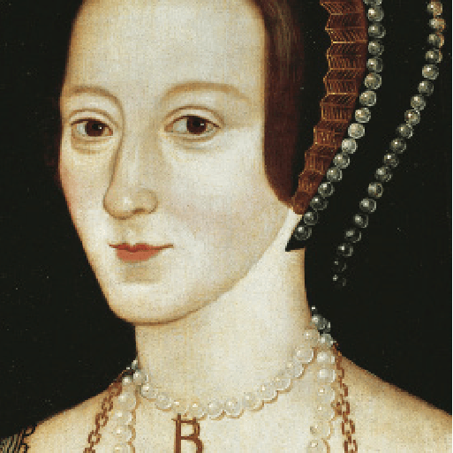
Off with her head! What sort of man would order the beheading of his wife? In fact, not just one wife but two wives! Travel back in time to the 1500s and meet the terrifying Tudors, a domineering dynasty that brought about astonishing changes to our country. Discover an opulent court where dancing and singing went hand in hand with swift falls from favour, and even swifter falling of heads. Develop your painting skills, solve riddles and remember to protect your precious neck with a large white ruff if you want to survive at Tudor court! Flex your detective muscles and become a criminal investigator. How will you find the accused, innocent or guilty? It’s your turn to take part in one of the most famous trials that the world has ever known.

English: The children will be learning the features of legends as well as writing their own based on the classic 14th century tale of “Gawain and the Green Knight.” They will also be focusing on persuasive writing: this will be a great opportunity for the children to use their skills of persuasion to put across their point of view in a constructive manner. There will continue to be opportunities each week for creative story writing.

Maths: We will begin the term by learning about geometry and then moving on to learning about position and movement, including coordinates, translating and reflecting shapes. This will be followed by a focus on measurement involving length, mass, time and temperature as well as area and perimeter. Number work will continue during our Fast Maths lessons.

Science: We have a new topic this term – forces. The children will have learned about forces further down the school so we will be building on that learning and increasing our understanding of gravity, Newton, water resistance, air resistance and mechanisms.

Computing: This half term we will be exploring a new area of learning entitled ‘Communication’. This will entail web searching, selecting search results, how searches are influenced and how we communicate responsibly.

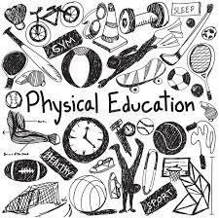P.E. is still with the Sports Coach on Tuesdays and Thursdays so please remind the children to bring their PE kit on those days. Long hair must be tied up and earrings must be taken out or tape should be provided. No other jewellery should be worn. Water bottles are essential. Swimming will continue to be on Friday mornings from 28th April; please remind children to bring in their costume, a towel and goggles (if required) every Friday.

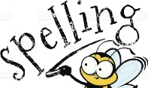
Spellings will be given every Friday and there will be a test each Wednesday. Please do look at the spellings as many times as possible.

Homework will also be handed out on Thursdays and then should be returned by the following Tuesday.

Dates for the Diary
Monday 1st May: May Bank Holiday
Monday 8th May: Coronation Bank Holiday
Monday 22nd – Friday 26th May: Specialist Week- details to follow
Friday 26th May: Break up for half term.
Tuesday 6th June: Pupils return to school.

Once again, thank you for your on-going support.

Mrs Blurton, Mrs Barringer, Mrs Sharp and Miss Saville.

