**Barleyhurst Park Primary School**

**Year 3 Monkeys**

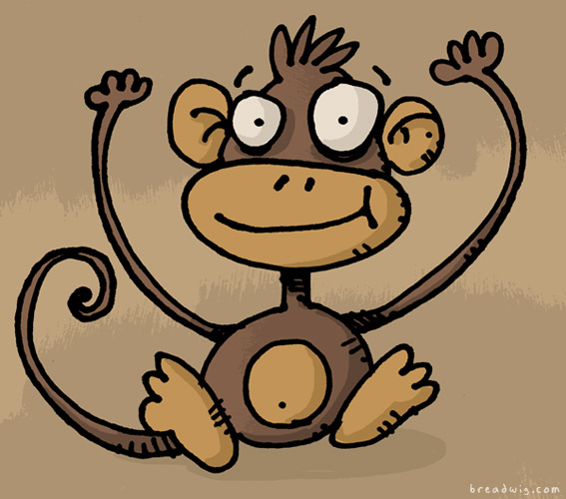

**Autumn Newsletter 2025**

**‘We try our best, we swing to success.’**

**Welcome Back!**

Welcome back and welcome to a new school year. We are delighted that you are joining us in Year 3. We have an exciting term planned, with interesting topics, forest school, science experiments and new books to enjoy. Mrs Hughes will be in class on a Monday, Tuesday and Wednesday and Miss Bailey will be in class on a Thursday and Friday. Mrs Barringer will be supporting us for much of the week.

**P.E.**

We will have P.E. on **Tuesdays** and **Thursdays.** Please come into school on those days in **full P.E. kit**, including joggers and a jumper on cooler days. Please remember that long hair must be tied up and jewellery left at home. We will also begin cross country sessions, which will be embedded into our P.E. lessons.

**Forest School**

Forest School will take place on **Monday** afternoons every week. Please also come into school in P.E. kit on a Monday. In addition, you will need **wellies** and **waterproofs**. On colder days, please wear layers. We will be outside in all weathers and without the correct clothing it can get a little miserable!

 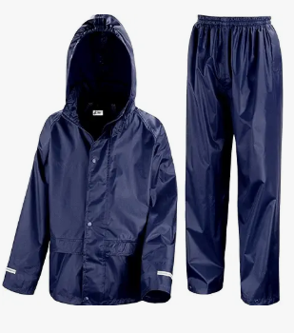 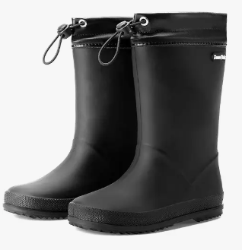

**Topic**

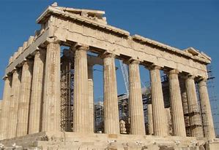

Our first topic will take us back in time to Ancient Greece!

We will learn about the landscapes, climates, people and the gods who were such an important part of everyday life in Greek times. Pupils will use their research to produce fact files packed full of interesting information. In addition, we will be learning some Ancient Greek dancing.

**English and Maths**

Our first lessons in English will be a consolidation of the sentence - level work that the children completed within their time in Year 2. Our first book study will then commence, and I know the children will love the story! We will be reading ‘Ottoline and the Yellow Cat’ and focusing on the genre of mystery stories. At the end of the unit, the children will have the opportunity to write their own mystery story.

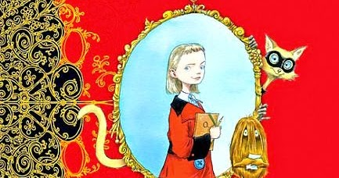

In Maths, we will begin the year with a focus on numbers up to 1,000 and how we can compare, order and partition them. The children will continue to learn their times tables and will be given their TTRS login details. More information to follow!

**Science**

During our science lessons the children will be learning about healthy eating and an active lifestyle. This will include learning about the muscles and bones in the human body.

**Homework**

Pupils will be set homework on Thursdays, and it must be returned by the following Tuesday. Spellings will be set on Spelling Frame each week- more information to follow! It is also essential that you continue to listen to your child read every day. Please record this in their reading record.

We are really looking forward to getting to know you and your children better.

Miss Bailey and Mrs Hughes