**Year 4: Meerkats**



‘Ever alert and ready to learn!’

**Autumn 2023**

Welcome to the Autumn Term of Year 4. We hope you are all well and have had a lovely summer break.

We are looking forward to the year ahead and hope to deliver an exciting curriculum for the children to enjoy. We will continue to create a safe learning environment for everyone.

We will be spending the first week of term establishing a strong classroom routine, as well as getting to know the pupils and the things they enjoy most. We will also be jumping into our Year 4 curriculum; our new topic is called ‘I am warrior!’ and will take us through the historical era of the Romans.

Our Maths lessons will focus on place value, multiplication and division. In English, we will be focusing on spellings, punctuation and grammar for the first two weeks. We will then be moving on to a two-week non-fiction unit based on instructions and explanations. Towards the end of the first half term, we will explore fables, myths and legends.

We will also be completing interesting Science lessons based around teeth. Mrs. Hughes will be planning exciting computing sessions where pupils will create multimedia presentations and Mrs. Wheeler will continue her weekly Italian lessons. On Wednesdays, the children will have a percussion music lesson. We’ll also have Forest School sessions on Fridays. For Forest School, the children will need to come into school in a PE kit but they will need to wear jogging bottoms as lots of the work will involve being in the outdoor environment. A change of shoes is also advisable as the weather changes. Wellies would be ideal!

We hope the children enjoy every aspect of their learning and look forward to seeing them progress through the Year 4 curriculum.

Times tables

As children enter Year 4, they will see there is a big push on their times tables. Learning their times tables has many benefits across the Maths curriculum, but children also get assessed on their times table recall towards the end of the year. One of the things we do to help children learn their times tables is to give them access to Times Tables Rock Stars, an online platform based around answering times table questions. The children will be getting their login details this week.

Below are some frequently asked questions. You will also receive a Parent Guide for additional information.

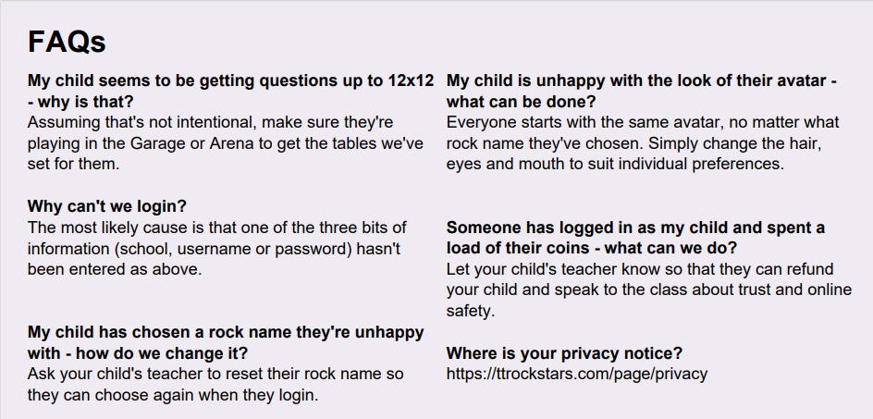

**Reminders:**

• PE will be on Mondays and Fridays. PE kits should be worn to school on our PE days with long hair tied up and earrings out (or covered with micro-pore tape).

• Forest schools on Fridays required a change of footwear and a waterproof jacket when the weather turns.

• Pupils will have a reading book/ library book sent home this week; please listen to your child read as often as you can and then sign their reading record. If you are also able to ask them questions about what they have read this will help them to develop their comprehension skills.

• Homework will come home on Thursdays and will be due back by the following Tuesday.

• Spellings will come home each Monday and pupils will be tested the Friday.

Thank you for your continued support,

Miss Vaughan and Mrs. Hughes