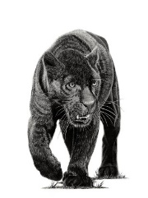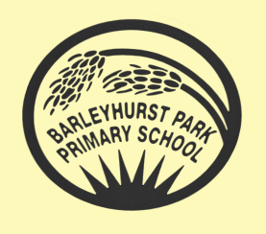**Year 5**

** PANTHERS CLASS NEWSLETTER**

**January 2025**

Happy New Year! Year 5 staff wish you a warm welcome to the spring term of 2025. We have so much to look forward to and lots of exciting activities planned.

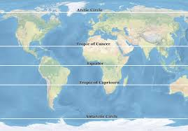

Our new topic is called Investigating Our World where we will learn about some of the major geographical features of our planet such as mountains, rivers and volcanoes, as well as studying lines of latitude and longitude. Also, we will look at Ordnance Survey maps of our local area and learn about different landscapes and climate zones of our planet.

Tick, tock, tick, tock. The hands on the clock never stop! But what if the clock struck 13? In Tom’s Midnight Garden, our class text, Tom travels in time. Imagine that you could time travel too. When would you like to travel to and what would you like to see? Will you head back to your past or into your future? You decide!

In English, we will begin by looking at our class text, before moving on to explore a range of newspaper reports, culminating in writing a report of our own. During our guided reading sessions there will be a variety of both fiction and non-fiction texts to widen children’s reading and to enhance their prediction, inference, explanation and retrieval skills.

In Maths, we will be working with fractions and decimals. These chapters develop pupils' ability to handle more diverse problems involving fractions, including dividing and multiplying fractions by whole numbers.

In Science, we will be starting a new and exciting topic, Earth and Space. So, get your rockets ready and count down from 10 for a blast off into a whole other world filled with facts, enquiries and opportunities to have questions answered as well as investigate the solar system.

In Computing, we will look at creating vector drawings. The children will learn how to use different drawing tools to help them create images. We will recognise that images in vector drawings are created using shapes and lines, and each individual element in the drawing is called an object. Children will layer their objects and begin grouping and duplicating them to support the creation of more complex pieces of work.





Our P.E. sessions are on, Tuesday, Thursday and Friday. Children should bring their P.E. kits to school on Tuesdays and Thursdays. Remember that long hair should be tied up and earrings taken out or covered with micropore tape. On Fridays, year 5 pupils will be continuing with their swimming sessions so please remember swimming kits and towels each Friday. Any earrings will need to be removed for swimming.



Homework will continue to be set on a Thursday and should be handed in by the following Tuesday at the latest. Homework should be completed to the best of the pupil’s ability. In addition to this, don’t forget to keep on encouraging the children to read as often as possible and continue learning their times tables and reciting them.

Spellings should be practiced everyday if possible and the look, cover, write, check method should not be done in one go, but spread over the week so that the spellings are learnt with confidence and children are ready for the test each Monday.

If your child is uncertain about any of the homework set, they can ask a member of the Year 5 team, before it is due in, for extra support and guidance.

Thank you for your continued support and communication. We are all so pleased with the effort the children put into their work in school and at home.

Mrs Blurton and the Year 5 team.