Barleyhurst Park Primary School

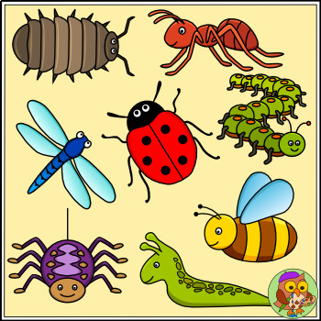

“Lovely Lions look, listen and learn. We can do it, we
will do it, we will do it well.”
'Minibeasts'
Lion Class

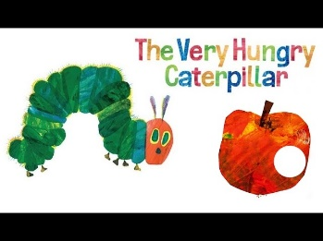
Welcome back lovely lions! I hope you all enjoyed the half-term break. We cannot believe that it is the last few weeks for the Lions, and then we have to say goodbye! We are committed to doing everything we can to get them ready for Year 1 and having a lovely time before they leave!
What the children will be learning:
Communication, Language and Literacy
- Learning to use well-formed sentences when talking in class or with Talk Partners.
- Continue the development of letter-sound recognition and formation.
- Writing their own rhyming poem.
- Development of reading skills and enjoyment of books.
- Writing their own fact book about minibeasts.
- Develop their writing skills by writing instructions for a snail race.
- Sharing the stories ‘The very hungry caterpillar’ and ‘The bad-tempered ladybird’ by Eric Carle.
- Using capital letters and full stops in their writing.
- Learning Monster Phonics focus and high frequency words.

Mathematical development
- Continuing to read, write and order numbers 1 to 20.
- Continuing to count beyond 20.
- Continuing to learn about the composition of numbers to 10.
- Learning to recognise and continue odd and even number patterns.
- Learning about doubling and halving.
- Learning about sharing objects and numbers equally.

Understanding of the world
- Finding out about different types of minibeasts.
- Sorting minibeasts into different groups according to one or two criteria.
- Learning about the lifecycle of a caterpillar.
- Exploring the natural world around them and looking after plants.
- Learning about healthy food choices by making a fruit kebab.
- Learning about how to look after our teeth.
Expressive arts and design
- Designing and building junk model minibeasts.
- Construct with different materials.
- Learning to use imagination and newly learnt vocabulary in our role-play areas.
- Making observational drawings of minibeasts.
- Sewing a felt ladybird.
- Learning songs for Father’s Day.
- Making a clay snail.

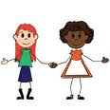
Personal, social and emotional development
- Discussing changes in our lives in preparation for moving into Year 1.
- Activities to encourage independence, concentration and confidence.
- Building self-esteem through positive feedback, reward charts, star reader and writer rewards, reward wall (yellow achievement stars from home), and star of the week assemblies.
- Continuing to follow our classroom rules and routines.
- Thinking about our own community.
- Learning to make new friends and share friends.
- Managing emotions.

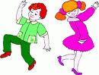
Physical development
- Developing fine motor skills through a variety of activities: bead threading, sewing, using finger puppets, cutting with scissors and using loose parts.
- Developing an awareness of space.
- Using large play equipment safely.
- Focusing on ball handling skills.
- Developing the understanding of healthy eating.

Your support
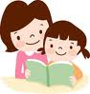
We hope you can assist your child in their learning by:
- Reading their Monster Phonics e-books with them regularly and writing a brief comment in their reading record.
- Helping them to learn their focus and high frequency words.
- Ensuring all items of clothing are named.
- Ensuring that they come to school wearing the correct P.E kit on Monday, Wednesdays and Fridays.
- Completing the Learning Journal task at home. It is posted through Tapestry every Friday or Monday.
- Useful websites: www.topmarks.co.uk, (early years section) www.bbc.co.uk/cbeebies , www.phonicsplay.co.uk (phase 2 and 3 games), www.iboard.co.uk (4-7 years).
Thank you for your continued support.
Mrs Wheeler and the Foundation team

