Year 6 Gorillas Newsletter: June 2023

It seems everyone had an enjoyable half term break. Once more, all pupils have been a real credit to themselves with the way that they have returned to school: positive about their learning, ready to work hard and making good choices.
This half term is the final half term at primary school for all of the pupils in Year 6. By the time this academic year finishes, the children will have: completed their independent writing; rehearsed and performed their end of year play; prepared for secondary school; and participated in some fun end of year activities. Hopefully we will have some traditional, sunny June and July weather for these activities.
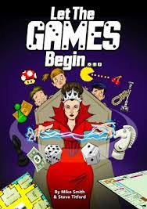
Some pupils may have already brought home their scripts to learn their lines for the part (or parts) that they have been assigned for the school play. More information about the play – Let the Games Begin – will be sent out in due course. In the meantime, please encourage your child to learn his/her lines and to read them loudly enough so that they can be clearly heard.

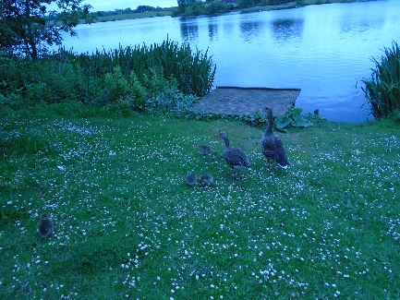
Before half term, we had Challenge Week. In Year 6, we completed a range of challenges including: walking to and around Furzton Lake; completing a number of sporting challenges; competing in the Ready, Steady, Cook challenge; and participating in a paper aeroplane challenge. My personal favourite was the wonderful walk around Furzton Lake.

This half term, we will continue to complete work linked to our topic (ID). We will also complete a range of activities that will help pupils to be better prepared for secondary school.
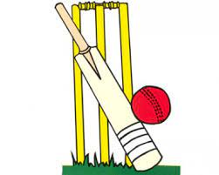
PE days
During the second half of the Summer Term, we will be having some additional PE lessons on Tuesdays. Please can pupils come to school PE ready on these days and bring their uniform in a bag to change into after PE.
Monday, Thursday and Friday PE will remain as normal.
On Mondays, pupils should also come to school PE ready but with their uniform in a bag to change in to.
On a Thursday and Friday, pupils should wear normal uniform to school and bring their PE kit in a bag to change in to before the beginning of their PE lessons.

Finally, please remember to encourage your child to complete their homework to the best of their ability as this is good preparation for secondary school. If your child is unsure about how to complete a piece of homework, then encourage them to speak to an adult at school before it’s due in. Homework is due in on Tuesday, every week.

I’m very much looking forward to our final half term together.

Dates for the Diary
Tuesday 20th June: Year 6 enrichment day at Willen Lake
Friday 21st July: Final day of the Summer Term

Kind regards,
Mr Cunningham and the Year 6 team

