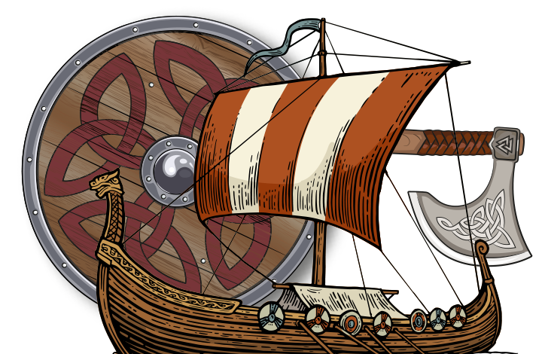

**Year 4: Meerkats**

**Summer Newsletter**

April 2024

**Welcome back!**

It has been fantastic to see the children back at school after our Easter break, and it has been wonderful to see everyone returning to school with such a positive attitude to learning.

The Summer Term is always one that we look forward to for many reasons and hope the children are just as excited as we are about our last term together in Year 4. As ever, there will be plenty of opportunities for the children to show how much progress they have made and to learn new and exciting things.

**Raiders and Traders**

Our new topic is ‘Raiders and Traders’. An exciting unit based on the Anglo-Saxons and the Vikings. We have also linked a new class text with this particular time in history. We have already started reading ‘Invaders’ by June Crebbin and the children have been very enthusiastic about the English lessons based on it. We have planned many exciting opportunities in our lessons for exploration and discovery. We’re really looking forward to sharing new information and tasks about this interesting era of history. Furthermore, the children will have an opportunity to show off some of their art skills throughout the term as we use different mediums to produce art inspired by our topic.

This half term, we will be focusing on stories with historical settings, as well as reading and writing non-fiction texts. We will be studying key number skills, money, mass, volume, length and area in our maths lessons. In science, we will find out about electricity and attempt some experiments. We will continue to have percussion lessons on Wednesdays, as well as Italian with Mrs Wheeler on Tuesdays.

Our weekly PE slots for this half term are on Mondays and Fridays. Pupils should continue to come to school dressed in appropriate kit. Correct PE kit should consist of a t-shirt, shorts (or jogging bottoms) and footwear. Earrings should be taken out or covered, and hair should be tied back. We are aiming to use our school field as much as possible as the weather warms up!

**Homework**

As always, homework will be set every Thursday and is expected to be completed and returned to school by the following Tuesday. In addition to the homework that is set, all children should be reading at least three times a week at home and practising the weekly spellings.

Thank you for your continued support.

Kind Regards,

Miss Vaughan and Mrs Hughes