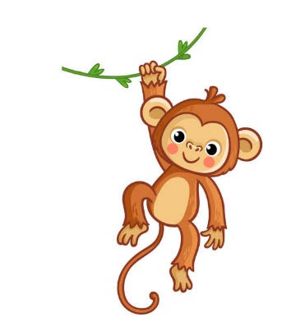Year 3 Monkeys

Spring 2, 2025

Welcome back to another half term in Year 3!

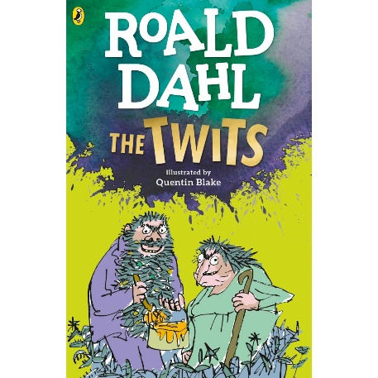The children had a very enjoyable Specialist week learning so much about global warming and creating some super artwork using plastic bags and other recycled materials. They even enjoyed performing A Recycle Rap in front of the whole school! It was good to catch up with the parents at the parents’ evenings and discuss your child’s strengths and targets for this half-term. I am sure that most of the Monkeys are ready for new challenges and exciting learning opportunities this half-term!

This term in English and Maths…

In our English lessons, pupils will be studying the Twits by Roald Dahl and learn about using direct speech in writing. Later, they will be looking at different types of poetry.

In maths, we will be focusing on money and time. Lessons will include first-hand experiences, book work using our Maths No-Problem scheme and interactive tasks. They will continue to use different calculation strategies for all four operations.

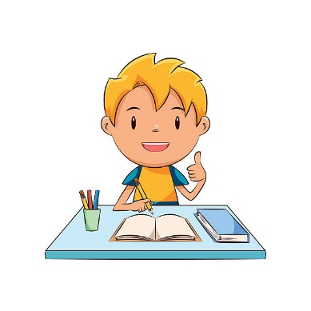

This term in P.E.

Our P.E. days continue to be on Mondays, Thursdays and Fridays. The children will be doing Athletics and tennis. When the weather is cold, it is important that the children wear joggers as some of the PE lessons can take place outdoors. We would also like the children to use micropore tape on P.E. days to cover their earrings.

Homework….

The homework is handed out every Thursday and needs to be completed by the following Tuesday by the latest. Please let us know if your child finds it either too tricky or too easy. The spellings will be available on the SpellingFrame website each week for practice at home, and the test will be every Friday. Please ensure your child is only using the Practice Mode at home.

As always, do not hesitate to contact me, if you have any queries.

Kind regards,

Mrs Wheeler and the Year 3 Team

This term in Topic…

This half-term the children will be learning about human and physical features in Geography. They will be classifying and comparing different types of geographical features. They will also use some primary data by observation and investigation and by doing some field work and studying maps.