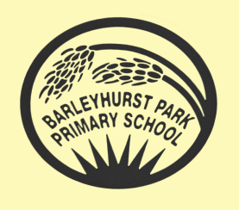
YEAR 2
Giraffes
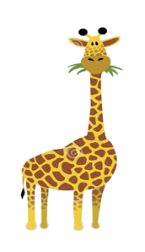
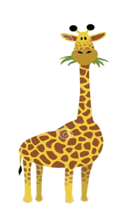
NEWSLETTER SEPTEMBER 2026

Welcome Back!
A warm welcome back to Barleyhurst Park for the new academic year!
We hope you have all had a lovely summer break and are now feeling refreshed and ready for an exciting year ahead as part of the Giraffe class. I hope we can work together to make sure all the children in the class make progress, have fun and continue to develop into wonderful members of our school community!


English
In English this term, we will read a range of seaside stories and use the coast/sea/ocean as settings for our writing. Our focus will start on ‘The Snail and the Whale’ and ‘A House for a Hermit’ by Eric Carle and information books to write labels, lists and captions, tongue-twisters, stories, letters and postcards. We will also use the internet to search for facts about the seashore and use that knowledge to write our own non-fiction texts
Maths
In Maths Giraffes will revise place value and work with numbers up to 100, comparing them and using them in number bonds. Then we will move on to the four operations , be introduced to new methods and recap those that they are already familiar with. Please take any opportunity to recognise numbers in any situation, whether it be at the supermarket looking at prices, counting objects in 2s, 5s or 10s or playing a board game!
Science
In Science, we will be learning about living things and their habitats. We will be sorting things into groups of living things/things that have been alive and non-living things, exploring different habitats and learning about food chains and basic needs of animals.

Beachcombers
Do you like to be beside the seaside? That’s good because you’re about to become expert beachcombers.
Our topic for this term is ‘Beachcombers!’ So, pack up some sandwiches, pick up a fishing net and keep your eyes peeled because we are off to the coast to go beachcombing! This will be a geography and history-based topic as we will look at the features of a beach but also the historical differences between the Victorian seaside.

If you have been lucky to have visited a seaside over the summer, please bring in any photos of you having fun in the sand or sea! We’d love to hear all about your adventures and use your photos for our wonderful display.

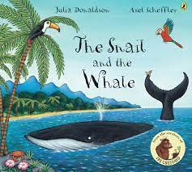




Extra information…

Our PE sessions this year are on Mondays, Tuesdays and Fridays. Please make sure your child comes to school wearing the correct PE kit (short or long sleeves and shorts or jogging bottoms/leggings, depending on weather conditions), long hair must be tied up and earrings must be removed or covered with micropore tape before arriving to school. We will also be having Golden Mile runs/walks throughout the week!

Spellings will be sent home on Mondays, and the children will be tested on the Friday. They will bring home a practise sheet on Mondays and they have all week to practise at home and return their sheet on a Friday. It is really important that the children complete this activity each week as part of their homework!

Homework is set on a Thursday and is due in by the following Tuesday.



How can you help your child?
- Listen to them read each day. You should all have a log-in for MONSTER PHONICS ebooks and we will be letting you know which Stage and book number they should start at.
- As usual the children will visit the school library once a week so please make sure the book is in their book-bag each week. When they do read to you, please make a note in their reading record (this can be your signature or a short comment). I like to reward children who try to read at home!
- Ask them questions about what they have read.
- Encourage them to practise their spellings every day, using the ‘LOOK, COVER, WRITE, CHECK’ method.
- Support them in completing their homework.
- Go to your local library to find books about their current topic.
- Ensure your child wears their PE kit on the days they have PE lessons.
- Provide a named water bottle for them to use in class. These can be purchased from the school office.

I look forward to meeting you all over the course of this first half term. Whilst I always endeavour to discuss any issues that arise very promptly, it isn’t always easy to do that at the start of the school day. If this is not possible then please always ring into the office or email the office with any questions/queries or problems you may have as a family and I will make contact as soon as is possible during the school day.

Thank you for your support,
Mrs Burns

