Barleyhurst Park Primary Nursery

Bears Newsletter

Spring 1, 2025

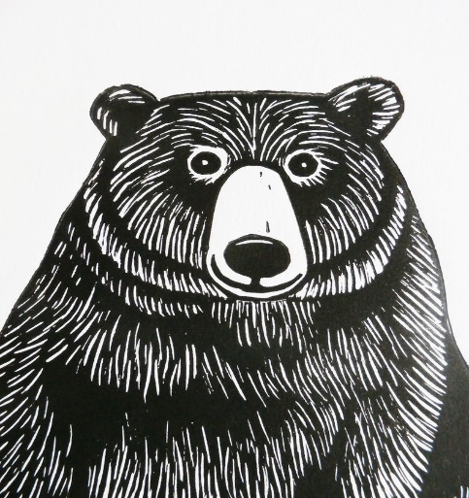

Brilliant Bears are always busy!

***Welcome!***

Welcome back Bears! What a busy first term the bears had. The Nursery team and I were so incredibly proud of all the children during the lead up to Christmas. There were lots of changes to our daily routines which the children coped remarkably well with. We hope you enjoyed watching our Christmas performance. The children spent many weeks learning the songs and actions. It was wonderful to see so many of you in the audience. Most children also enjoyed staying at Nursery to have a Christmas dinner, potentially trying new food. We hope you all had a wonderful holiday.

The children also enjoyed learning about and sharing their experiences of different celebrations such as Bonfire night. We also had lots of fun thinking about what makes up our world. We painted on ice, made our own boats and created animal patterns that would be found in the rainforest.

This half term we will continue to set up lots of different learning opportunities for the children to explore inside and outside! We will also be spending time modelling how to use the different areas of learning safely with our friends.

We will support the children to become familiar with our daily routines such as self-registration, calendar, ‘busy bear time’, snack time, ‘sing and rhyme’, lunchtime, focused group time, write dance and Storytime. We will continue to have focused learning group time with all children and to have a morning P.E session with the school sports coach.

The children will be exploring and learning with all the key workers within the Nursery: Mrs Wolfe (Nursery teacher), Mrs Beach, Miss Stangroom and Mrs Hunt.

This half term our stimulus is *People/Animals who help us.* We will be setting up activities which reflect how different people and animals help us. We will be having an assistant dog spending the morning with us. His handler Karen will show us all the things he has learnt. We will also be thinking about the police service, postal workers, bus drivers, and nurses who help us. If you know anybody who would be willing to come into nursery to support our learning, please make me aware.

We will continue our mark making program *Write Dance*. It’s an exciting music and dance approach to develop the skills needed for writing, which also helps with co-ordination, balance, flexibility, and stamina.

We will be continuing to have a ‘helper’ of the day. A child will be given special jobs throughout the Nursery Day, most importantly choosing their friends to get ‘busy’ with their learning after registration. This is a time of day we know the children enjoy and get very excited about.

Before we start each session in Nursery, we ask the children to remember three things, **Be Kind, Be respectful, Be safe.** Our golden rules will continue to be displayed and discussed.

We will be continuing our ‘dib’ box. Each child will be rewarded when an adult observes the children being, **Kind**, **respectfu**l and **safe**. They will get a sticker for our class chart and once they have five, they will get a ‘dib in the box’- a prize and then start to build up their next five stickers.

**Please remember:**

* Bring a named bag of spare clothes for your child.
* Name all clothing and bring an appropriate coat.
* If your child is in nappies, please supply nappies and wipes

in a named bag.

* If your child is staying for lunch, please supply a

named lunchbox. Please remember no chocolate bars, sweets or Fizzy drinks. No peanut butter and please cut up grapes (length ways)

* Please let us know if a different person is picking your

child up from nursery.

* If your child has any medication, please inform us.
* Parents /Carers are asked to drop off and collect from

the nursery door (a member of staff will collect parents/

carers from the main school gates).

* If your child has borrowed clothing from the Nursery, PLEASE return it.
* Please bring in a family picture (for a class book). We can print it off for you if you email to the school website. The children love looking at their family pictures and talking to their friends about their family.
* If your child goes home with any toys in their pockets, please return.
* The children visit our school library on Fridays. The children are to return the book the next Friday. The children will only be able to get out a new book on the return of the old one.

Thank you for your support, Mrs Wolfe and all the team.