Barleyhurst Park Nursery

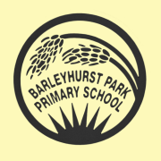

Welcome

Welcome

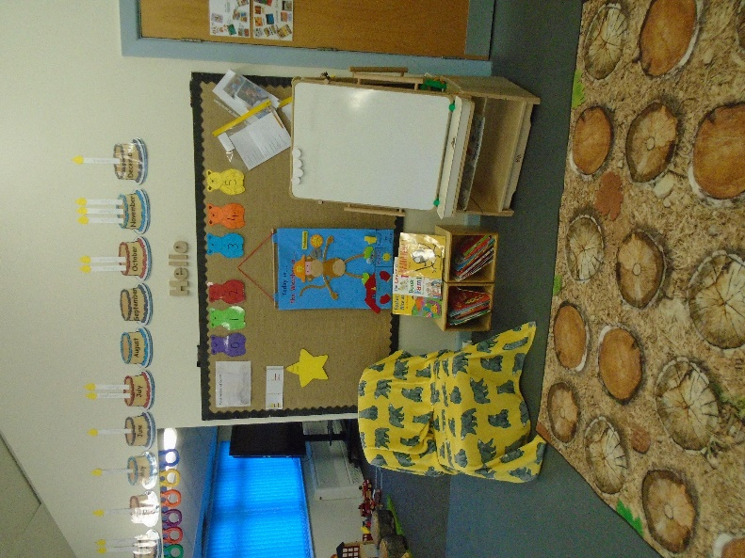
A warm welcome to our new nursery, we hope will be the start of your child’s exciting learning journey at Barleyhurst Park School. We are pleased to offer you an exciting new nursery; led by a fully qualified, experienced teacher, supported by an experienced Governing Board. Our learning space has been fully refurbished – indoors and outdoors – and resourced with new furniture and resources. We know that your decision on your child’s nursery placement is the first milestone in their school career. We are looking forward to working with your family to ensure we foster and develop a lifelong love of learning, in a safe, happy place.

Our induction process-for parents and carers

We have created this booklet to share the information we would have at that meeting. We hope it answers all your questions and gives an insight into how the children learn and play at Barleyhurst Park Nursery.

You will find all the important pieces of information in this induction booklet to ensure a smooth start to Nursery, including Nursery entry paperwork that will need to be completed.

Admissions

The Nursery class admits pupils who are 3 and 4 year olds. Admission forms are available from the school. Places are allocated in early April. Later offers of places can be made if there are any remaining spaces after the April admissions are confirmed.
Provision is offered for either:
• 15 hours = five mornings: 8.50 – 11.50
• 30 hours + lunchtime = five days a week, all day: 8.50 – 3.05
If you are not eligible for full time funding the cost of an afternoon session is £15 per session.

Children are admitted to the school’s Nursery class according to the following criteria:-

- Children who live in the defined area and have a sibling on roll at the time of admission. Proof of residence may be required.
- Children who live in the defined area served by the Nursery. Proof of residence may be required.
- Children who live outside the defined area and have a sibling on roll at the time of admission.
- Children who live outside the defined area of the school.

In the event of over-subscription, places will be allocated according to the proximity of the child’s home to Nursery as measured by the nearest available route.

Nursery class sessions morning sessions are from 08.50 to 11.50 and full day session is 8.50 to 3.05.
Outside these times, the school is able to provide additional childcare:
- Breakfast Club from 08.00 at £3.00 per session
- There is a no additional charge for ‘all day’ children to cover lunchtime care and supervision between the morning and afternoon Nursery Class sessions.
NB A place in the Nursery Class does not automatically confirm admission to the school.
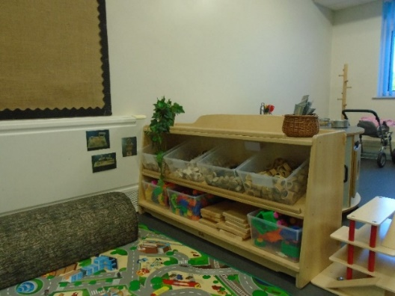
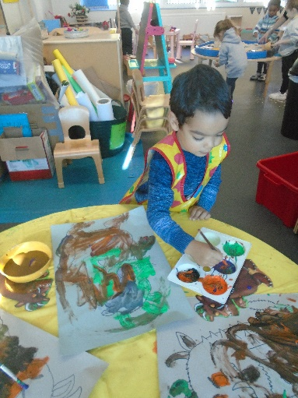
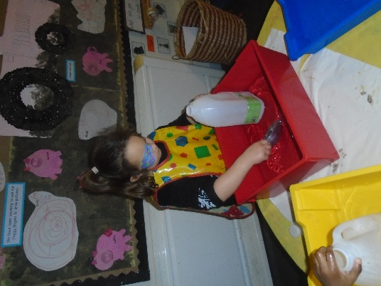
The Early Years Foundation Stage Curriculum

The Early Years Foundation Stage (EYFS) sets the standards for learning, development and care for children from birth to five.

The statutory framework for the Early Years Foundation Stage contains the legal requirements and statutory guidance which we follow.

There are four over-arching principles for the EYFS. These are:

- Every child is a unique child
- Every child is a competent learner from birth who can be resilient, capable, confident and self-assured.
- Children can learn to be strong and independent through positive relationships.
- Children learn and develop well in enabling environments in which their experience respond to their individual needs and there is a strong partnership between practitioners and parents or carers.

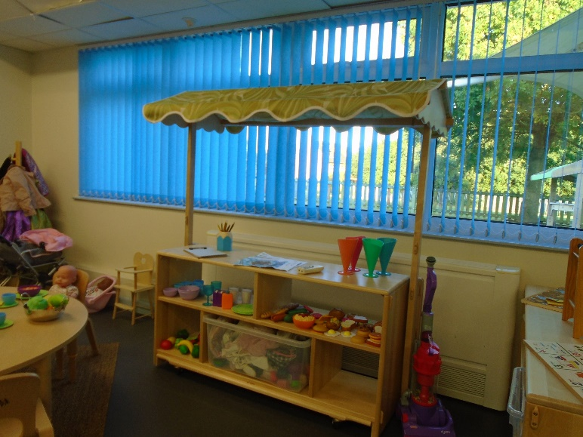
Children develop and learn in different ways and at different rates. The framework covers the education and care of all children in the early years including children with special educational needs and disabilities.

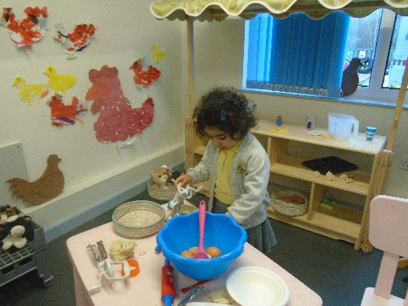

Learning and development

There are seven areas of learning and development.
All areas are important and interconnected.
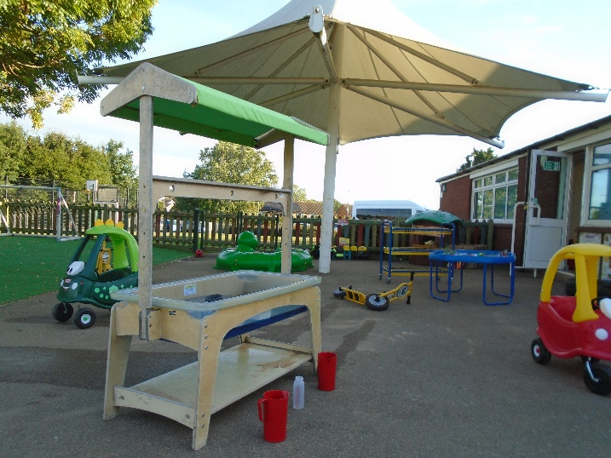
The prime areas are

- Communication and Language- Encouraging talking and listening
- Physical development - Physical control, mobility, awareness of space and manipulative skills in indoor and outdoor environments.
- Personal, social and emotional development- Learning how to work and play, co-operate and function in a group, develop personal and moral values, understand themselves and others.

The children are also supported in four specific areas, through which the prime areas are strengthened and applied.

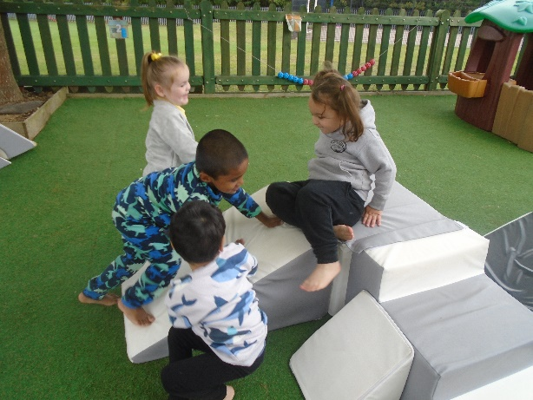
These specific areas are:

- Literacy- encouraging children to be confident and independent readers and writers.
- Mathematics- Mathematical understanding and the foundations of Numeracy, with a focus on practical maths.
- Understanding of the world - Finding out about the world around them, other people. These become a foundation for History, Geography, Technology and Science
- Expressive arts and design- The development of imagination and the ability to communicate and to express ideas and feelings in creative ways.

The Early Years team consider the individual needs, interests and stage of development of each child in their care and they use this information to plan a challenging and enjoyable experience for each child in all areas of learning and development.
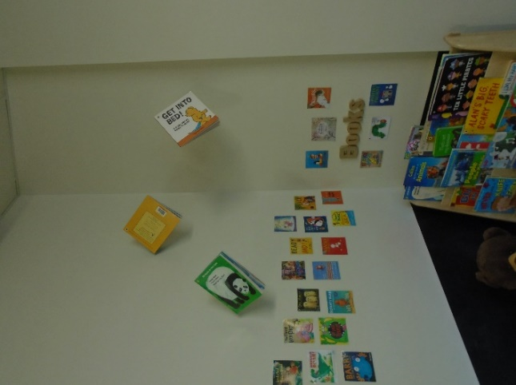
Leading learning in EYFS

The early years setting at Barleyhurst Nursery has a self-contained, well planned outdoor area with spaces for sand play, water play, digging, running, writing, reading and play. The children have free-flow access between the outdoor and indoor areas.

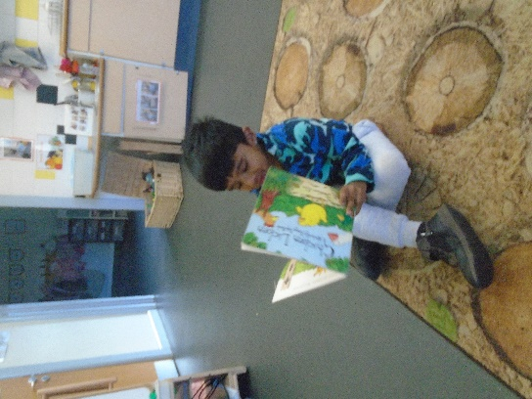
Play underpins the delivery of all the EYFS. Young children learn most effectively through structured play. We plan to ensure all seven areas of development are covered in an interesting, stimulating and supportive framework. We make sure the children progressively develop their skills and knowledge throughout this phase of their school life. The children are taught directly and also have a choice of planned activities so that they are able to develop independent learning habits. We actively encourage them to initiate their own activities.

We are very lucky to have a large indoor and outdoor area for them to use and explore.

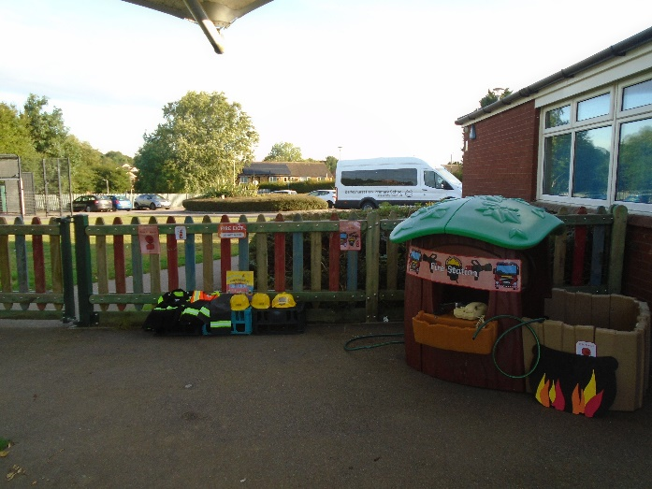
Indoors
- Role play area
- Construction area
- Writing table
- Fine and gross motor
- Mathematics area
- Art table/messy play
- Computer/Ipad
- Reading area

Outdoors
Bikes and scooters
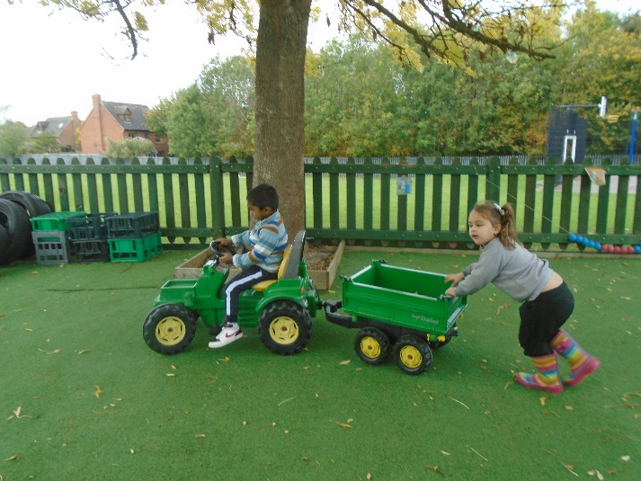
- Climbing equipment
- Play houses
- Writing area
- Reading area
- Mud kitchen
- Wildlife area
- Grassed area
- Sandpit

Home- school partnership

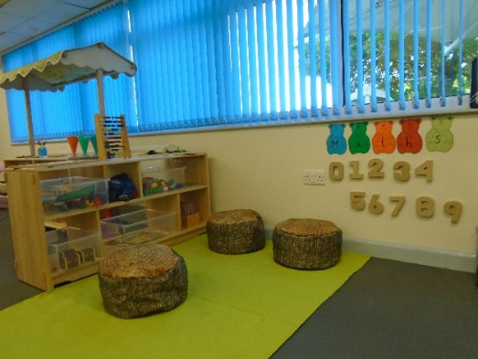
At Barleyhurst Nursery we like to foster strong links between home and school from the very start. This has a positive impact on children’s development and learning. A successful partnership needs a two-way flow of information. This is often done informally on a day to day basis before and after nursey, as well as through Tapestry (an online learning journal) and more formal parental consultations.

Tapestry is an easy to use online learning journal, Tapestry helps our school and parents to record, track and celebrate children’s progress and development. Text, images and videos can be easily viewed via PC, tablet or mobile app- anywhere there’s an online connection. Every entry helps create a complete story of a child’s time in EYFS at Barleyhurst Nursery.

Tapestry is like a window into your child’s EYFS learning where experiences are captured and shared with you. You can also share your child’s home learning by uploading it into their tapestry account.

A day at Barleyhurst Park Nursery

Barleyhurst Park Nursery aim is to ensure that all children learn and develop well in a safe and healthy environment. We ensure that children have the knowledge and skills they need to be school ready. In order to ensure children are ready we provide:
- A consistent daily routine – including registration, song time, focused group activity, snack time, free flow play and show and tell.
- A clear personal development plan for each child- which includes tracking and parental consultations.
- Key group structure-where children have time each day with their key worker lead.
- Healthy snack-we reinforce the importance of healthy eating habits. Our snack time is a great chance for children to try new types of food. We offer water and milk.
- Sport coach-the children will be given the chance to have short P.E sessions with the school sports coach.
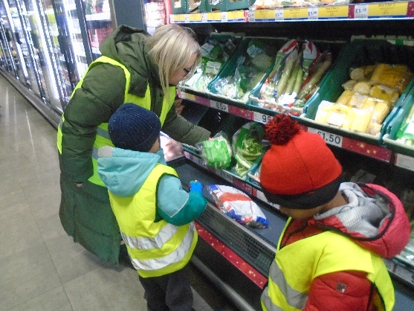
Trips and events

We aim to provide our children with a wide range of experiences and opportunities. We organise nursery trips, visitors and have WOW experiences throughout the year. Here are just some!

Autumn term
- Harvest festival celebration with parents Specialist book week. Children are encouraged to dress up as part of a given theme
- Nativity performance
- Christmas jumper day
- Christmas party day…with a special visitor
Spring term
- Mother’s Day celebrations
- Whole school specialist week
- Easter egg hunt
Summer term
- Father’s Day celebrations
- Whole school specialist week
- Sports day
- Nursery graduation (children who are now school age)

Reading together

The last Friday of every month Mums, Dads, Granny’s or Grandads can come into school for 15 minutes and share a book with their child.

Safeguarding

We have stringent policies and procedures in place to ensure that we act effectively in pursuing the five outcomes that ensure children’s wellbeing and that Every Child Matters. (HM Govt ‘Working Together to Safeguard Children’)

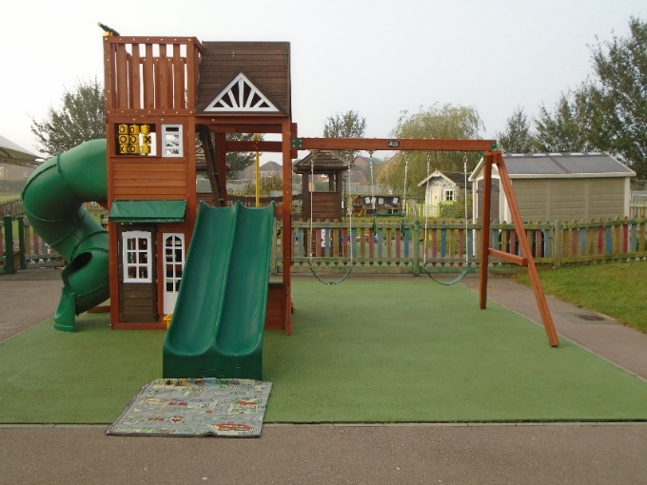
These outcomes are paramount in all our work. They are to make sure that all our children can:

- stay safe (in the context of this Safeguarding Statement, this is the main focus)
- be healthy
- enjoy and achieve
- make a positive contribution
- achieve economic wellbeing

The work of all professionals and agencies involved in safeguarding children and promoting their welfare is governed by a legislative Framework. We make sure we work conscientiously to fulfil all statutory requirements. In particular all our work and procedures are governed by the general duties set out in the Children’s Act, and the statutory guidance ’Working Together to Safeguard Children' (2006). We also work within the policy and practice guidance set out by MKSCB (Milton Keynes Safeguarding Children Board).
We have appropriate procedures in place for responding to situations in which we believe that a child has been abused or is at risk of abuse.
All our staff are trained in Safeguarding, and training is annually reviewed.
The designated person (named lead professional) for Safeguarding is Mrs W Smith, the Head teacher. Mrs K Wolfe is the Deputy Designated Lead for Early Years.

Inclusion
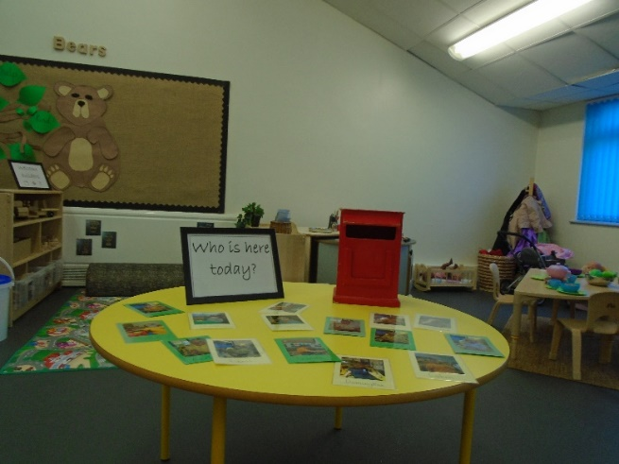
So, what does inclusion mean? It is to be included regardless of any specific, or general difficulties that children may have. If a child has a barrier to learning then we will need to give support (in some cases support of outside agencies) that removes that barrier allowing them to be included in all nursery activities.

Special Educational Needs and Disabilities (SEND)

"Children have special educational needs if they have learning difficulties which call for special educational provision to be made for them.

Children have learning difficulties if they:

- have a significantly greater difficulty in learning than the majority of children of the same age
- have a disability which prevents or hinders them from making use of educational facilities of a kind generally provided for children of the same age within the area of the local education authority.”
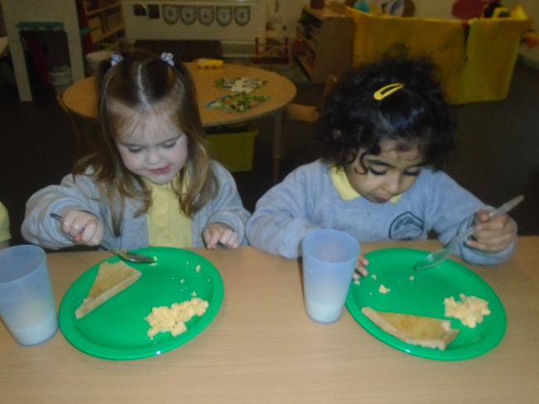
Food

All the children are able to stay for lunch. Parents must supply a lunchbox for their child from home. No fizzy drinks or sweets please. We encourage the children to be as independent as possible. Snacks will be available for the children attending Nursery.

Medical Matters

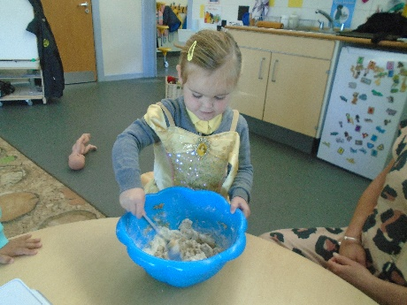
- Any sickness, diarrhoea, must be followed by 48 hours absence.
- Any absence requires a telephone call explaining why.
- Head lice are common! Please check regularly and treat as recommended.
- Any medicines can only be administered by school if prescribed by a doctor and is required four times a day.

Other services

We have strong links with outside agencies such as Speech and Language team and School Nursing Team.
Thank you

Thank you for taking the time to read this booklet. Please do not hesitate to contact us for any further information.
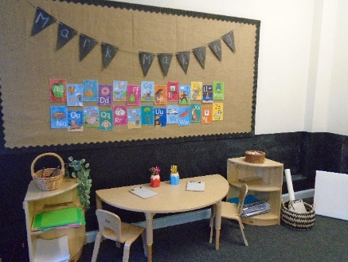
Visit our website
Barleyhurstpark.com
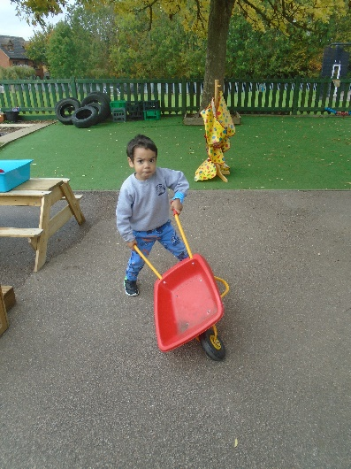
finance@barleyhurstpark.com
01908 378291
Forfar Drive
Bletchley
Milton Keynes
MK3 7NA

