Monkeys Newsletter – Spring 2, 2024

I can’t believe that the half term break marked halfway through our school year – the time has flown by! We had a wonderful specialist week before the break and the children excelled with their listening and appreciating of each other’s individual talents and beliefs. We created some wonderful artwork and learnt a whole song in sign to perform! The colour run was so fun for the children and we really appreciate all the money that our class managed to raise so thank you.
Moving forward we are now going into our second half of Year 3 and I hope we can move up some more book band levels, learn our weekly spellings, progress with our maths skills and behave in the way that I expect them to each day.
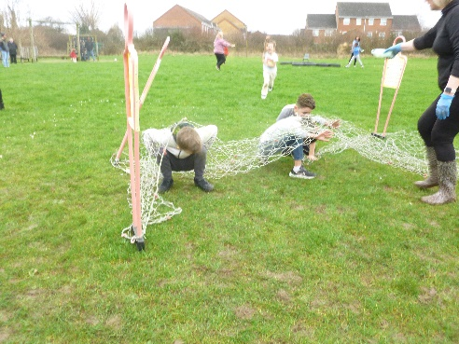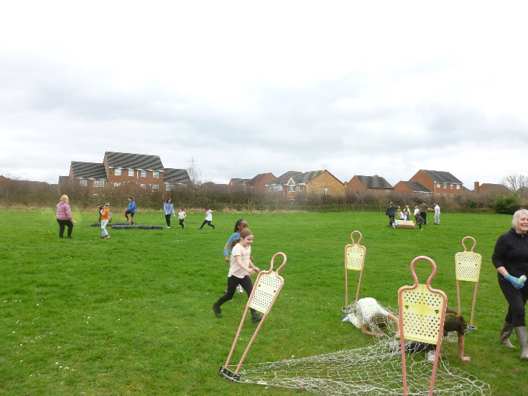

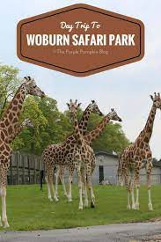
I know how much the children have enjoyed our topic ‘Predator’ so far and their enthusiasm has been wonderful! The birds of prey unit we are starting this half term will hopefully engage them further as they learn about these dangerous predators. Our trip this half term will be to Woburn Safari Park so hopefully we will see lots of real-life predators! Any contributions towards the cost of the trip will mean that we don’t have to cancel so hopefully we can collect enough for the trip to go ahead.

In Maths this half term, we will be focusing on money and time. I really want all the children to be able to confidently tell the time by the end of Year 3 as it is such an important life skill. Any practise at home would be great!

Our English lessons will involve the reading of ‘The Twits’ and a study of Roald Dahl, which the children seem to be enjoying already. Through the study of the book, we will be able to focus on dialogue too and how to organise speech in their own writing.
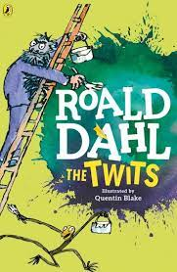 Reminder….cereal is served on Friday in Year 3!
We look forward to another great half term in Year 3. Thank you for your support, as always.
Mrs Burns and the Year 3 team.

