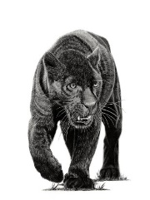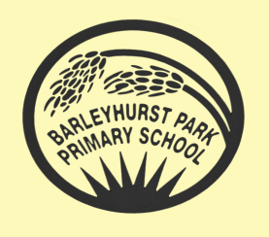**ThYear 5**

** PANTHERS NEWSLETTER**

**SEPTEMBER 2024**

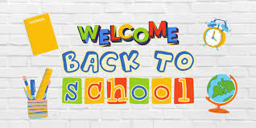

Welcome back everyone. I trust that you have all had a pleasant and fun-filled summer holiday. Hopefully you are feeling full of energy and ready to begin the year in Panthers Class.

I am Mrs Blurton, the class teacher and I am so looking forward to beginning our learning journey together as we have plenty of exciting topics, activities and lessons to keep us busy this term. Read on to find out more!

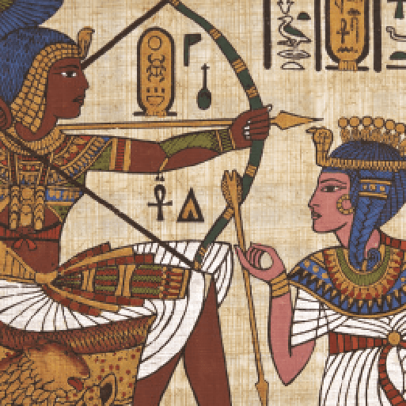

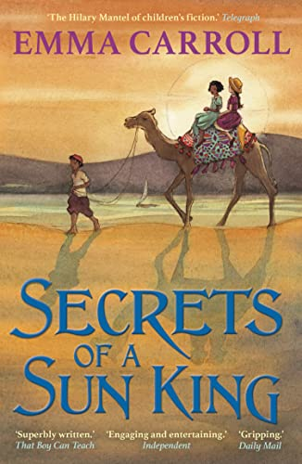

**TOPIC**

Our topic for the term is ‘Pharaohs’ where we will learn all about the Ancient Egyptians and their incredible history. Cruise along the Nile, entering a world of mysteries and curses, mummies and kings. Find out about life on the river’s fertile banks, discovering Egypt and its fascinating culture. Unravel the secrets of ancient tombs, using historical sources and ancient artefacts. Find out about powerful pharaohs and grandiose gods. Build your own pyramid and make your own Egyptian bread. Become an apprentice and work for Ramose, the chief embalmer at the Beautiful House. Help him prepare a body for its journey into the afterlife – if you dare!

**ENGLISH** 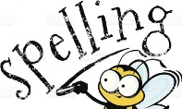

This term we will begin by learning how to write a non-chronological report. Following this, we will report on the discovery of Tutankhamun’s tomb in 1922 then move to the realms of fiction and write a mystery story (or two!) which will be based on our thrill-packed class text, “Secrets of a Sun King” by Emma Carroll. The children will begin to learn the year 5/6 spellings and increase their knowledge of punctuation and tenses.

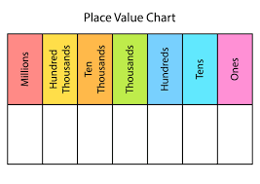

If you have any questions, please do not hesitate to contact me or the Year 5 team.

Best wishes,

Mrs Blurton.

**P.E.**

Our PE sessions this year are on Thursdays and Fridays. On Thursdays, now that you are in Year 5, you will change for P.E. inschool.Remember to tie up long hair and bring in micropore tape to cover up earrings (if you are unable to remove them yourself). On Fridays, you will be having swimming lessons so please bring your swimming kit into school every Friday (trunks or costume, towel, hair ties). ALL earrings will need to be removed for swimming. Always having the correct kit for P.E. is a small way in which you can begin to show independence. So, you must ensure that you bring your P.E. kit to school on each day that you have P.E.

**HOMEWORK**

Homework will be given out on a Thursday and is to be returned to school by the following Tuesday at the latest. Pupils should take responsibility for ensuring they complete as much of their homework themselves as best they can and handing it in on time.

Additionally, spellings will be set on a Friday ready for a spelling test the following Friday. Pupils should be learning these spellings at home alongside any other homework that has been set.

**COMPUTING**

This term we are learning to create a world and game in a programme called Kodu. We will learn how to create a world for a variety of characters, ending the term by creating a racing game with programmable characters.

**SCIENCE**

This term we will be learning all a variety of living things and their habitats. We will be exploring the differences in the life cycles of a mammal, an amphibian, an insect and a bird as well as describing the life process of reproduction in some plants and animals.

**MATHS**

We will continue to follow the National Curriculum for Maths focusing on place value and developing efficient mental and written methods for all four operations. Please continue to support your child with their times tables at home as this will improve their speed and confidence in Maths.