YEAR 2

**Giraffes**

NEWSLETTER JANUARY 2025





Welcome Back!

We hope you have all had an amazing break, whether you celebrated Christmas, or simply spent quality time with family and friends. Once again, we are very excited to kick start a new term with new topics and lots of new learning. We look forward to seeing you as we continue our exciting journey.

Yo-ho-ho! Get ready to ‘take to the high seas and set sail in search for treasure!’

This term our topic is called ‘Land Ahoy!’ I am sure the children will thoroughly enjoy the learning we have planned.

To kick start this wonderful and exciting topic, Giraffes are invited to **come to school dressed as a pirate on Tuesday 14th January** as part of our ‘WOW’ starter.

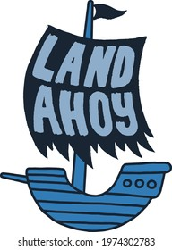

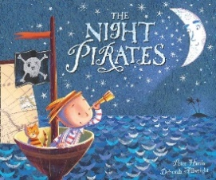

Our Learning

**In English,** we will be reading stories about pirates and information books, investigating amazing sea rescues and we’ll be writing postcards, letters, stories, and poetry influenced by the sea. We will be discovering Captain Cook’s diary entries and other non-fiction texts, followed by several fictional texts such as ‘The Pirates Next Door’ written by Jonny Duddle and many more.

In **Maths**, we will be learning how to solve word problems, working with money and 2D shapes. But we will be having a big focus on word problems and how to apply their knowledge when it comes to solving them.

In **Science**, our scientific thinking and science skills will help us to understand all about plants! We will focus on the different parts of a plant and what they need to grow healthily.

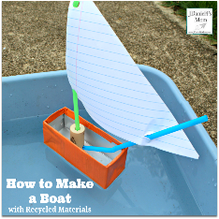

Weekly Routines

There will be minor changes to our PE sessions this term. The children will need to wear their PE kit on **Tuesdays, Wednesdays and Thursdays**. Please make sure the Giraffes come to school wearing the correct PE kit (short or long sleeves and jogging bottoms/leggings, depending on weather conditions), long hair **must** be tied up and earrings **must** be removed or covered with micropore tape **before** arriving to school.

Forest School sessions will resume on Wednesdays and the children will only be allowed to participate if they have a change of shoes in school. It’s too muddy and wet!

**Spellings** will be sent home on Mondays and the children will be tested on the **Friday**.

**Homework** is set on a **Thursday** and is due in by the following **Tuesday**.

How can you help your child?

* Listen to them read and give them access to the e-books at least 3 times a week. When they do read to you, please make a note in their reading record (this can be your signature or a short comment). Remember that repetition is key for fluent reading so read the same book as they are focusing on in school.
* Ask them questions about what they have read. Encourage them to find evidence in the books or quote what has been said or done.
* Encourage them to practise their spellings.
* Support them in completing their homework.
* Ensure they have their school library book ready to change **every Friday** please.
* Please **name** all jumpers, cardigans and fleeces as we have a pile of lost property already!

Lastly and very importantly, **thank you** **so much** for your kind gifts, cards and well wishes that we received just before the break and for your ongoing support, we look forward to another fabulous term ahead. Please do not hesitate to ask any questions to myself or any of the Year 2 team.

Kind regards,

Mrs Burns and the Year 2 Team