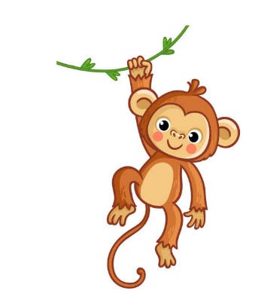Year 3 Monkeys

Spring 1, 2025

Welcome back to another half term in Year 3!

What a super first term the Monkeys had in the autumn! They thoroughly enjoyed our Ancient Greek topic and produced some excellent work including art.

It has been good to observe how enthusiastic the children can be about each and every subject! They have really focused on improving their times tables, using written methods for calculations and using prepositions and adverbs in their writing. Thank you for your continued support with homework, spellings and reading. It really makes a huge difference to practise their skills at home.

This term in English and Maths…

In our English lessons, pupils will be looking at different settings in stories. We will begin with a book study on ‘Storm’ by Kevin Crossley-Holland. Your child will also be taking part in drama work, research projects and reading comprehension tasks based on our new topic.

In maths, we will be focusing on length, volume and mass and related problem solving. Lessons will include first-hand experiences, book work using our Maths No Problem scheme and interactive tasks.

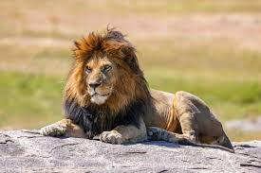

This term in P.E.

Our P.E. days continue to be on Mondays, Thursdays and Fridays. The children will be doing Indoor fitness and Netball. When the weather is colder, it is important that the children wear joggers as some of the PE lessons can take place outdoors. We would also like the children to use micropore tape on P.E. days to cover their earrings.

Homework….

The homework is handed out every Thursday and needs to be completed by the following Tuesday by the latest. Please let us know if your child finds it either too tricky or easy. The spellings will be available on Spellingframe website each week for practice at home, and the test will be every Friday. Please ensure your child is using the Practice mode only at home.

As always, do not hesitate to contact me, if you have any queries.

Kind regards,

Mrs Wheeler and the Yr3 Team

This term in Topic…

This term we will be continuing our exciting lessons with a new topic based on predators; with a focus on reptiles, birds and plants. The children will enjoy learning about some of the world’s deadliest creatures. Our Wow starter will be a look around the school grounds for any evidence of predators or prey this week. I am sure the children will love this topic as much as the Ancient Greeks and will be able to demonstrate their previous knowledge of dangerous animals!