

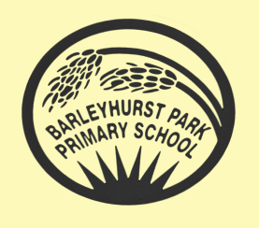
YEAR 2

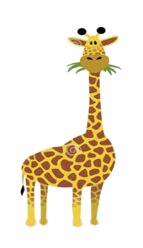
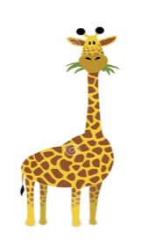
NEWSLETTER APRIL 2026

SUMMER 1

Welcome to the Summer Term of this school year. We hope you had a great holiday and enjoyed spending time in the sunshine with your family and friends. It was lovely to see all the children coming back to school enthusiastically and ready for new learning, which we are all very excited about.

Wriggle and Crawl
Our topic for this term is ‘Wriggle and Crawl’ and we will kick start our new topic by finding a variety of insects around our school grounds! Throughout the topic we will be gaining lots of knowledge and understanding about minibeasts, their habitats and what they need to survive, so we can answer a range of questions.

In English we will be reading ‘Traction Man’ by Mimi Grey which the children will love. We will be writing for different purposes, such as stories, lists and leaflets, instructions, reviews, and information texts.

In Maths, we will be learning about fractions, and how to tell the time. Any help with telling the time on an analogue clock will really help their progress with this.
In Science, we will consolidate our learning about living things and we will be working scientifically to investigate and learn about animals, including humans.
In History we will focus on how life has changed over the decades, starting with the 1950s. We will be looking at how things such as clothes, toys, homes, schools and technology have changed.
In Design and Technology we will be designing and creating a healthy sandwich wrap.
In PE Giraffes will be enjoying net wall games and some outdoor athletics. Please be sure to send them to school with the correct PE kit on Mondays, Tuesdays and Fridays. Earrings must be removed or covered with micropore tape before coming to school please.

How can you help your child?
• Listen to them read and fill in their reading logs as they love to get stickers for reading at home!
• Encourage them to practise their spellings every day.
• Support them in completing their homework.
• If your child is unsure about how to complete a piece of homework, then encourage them to
speak to an adult at school before it’s due in.
• Provide a named water bottle for them to use in class now that the weather is improving.

Weekly routines
• PE is on Mondays, Tuesdays and Fridays
• Spellings will be sent home on Mondays and the children will be tested on the Friday.
• Homework is set on a Thursday and is due in by the following Tuesday.

Key Dates
Monday 4th May: May Bank Holiday
W/C: 18th May: Specialist week
Friday 22nd May: End of Summer 1

Thank you for your continued support.
We are looking forward to teaching our lovely Giraffes this term.

Kind Regards,
The Year 2 team

