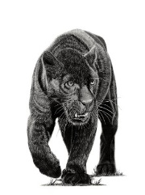
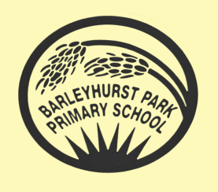
PANTHERS CLASS NEWSLETTER
June 2023

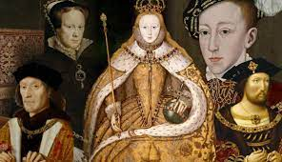

Hello everyone! It is so exciting to welcome the children back for their final half- term in year 5. All of the staff in Year 5 were so proud of the children for rising to the many challenges they were set in our specialist week at the end of last term; we hope they enjoyed them as much as we did.

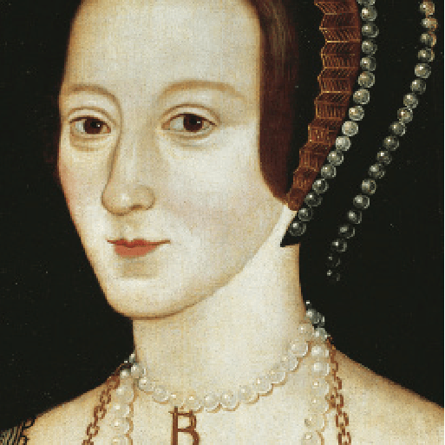
Off with her head! Our topic on the Terrifying Tudors continues. This term the children are focussing on the monarchs themselves and the changes they made to our country. They will also investigate famous battles, the beginnings of Empire and the role of pirates in the Elizabethan era. Not forgetting, of course, the spies, the treason, the music, the tasty food and the exciting dancing.

English: The children will be introduced to stories and poetries from other cultures from all over the world. As well as analysing the poetry, they will be reminded about figurative language and look at how it adds to the power of the poems. We will look at stories from across the globe, particularly from the modern era. Also, the children will be consolidating their basic writing skills in grammar and punctuation in preparation for their move up to year 6.

Maths: The term will start with more work on measurement before we move on to area and perimeter followed by volume and Roman numerals. As the term goes on, the children will be working on securing their skills with the four operations and answering word problems.

Science: This half-term, the children will be completing the topic of forces focussing on water resistance and mechanisms. The term will end with the pupils consolidating their knowledge of the science topics we have covered this year through lots of practical work and experiments.

Computing: This half term the children will be exploring programming. This unit explores the concept of variables in programming through games in Scratch. First, learners find out what variables are and relate them to real-world examples of values that can be set and changed. Then they use variables to create a simulation of a scoreboard. They follow this by experimenting with variables in an existing project, then modify them, before they create their own project which they design and improve.

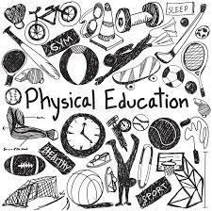P.E. is still with the Sports Coach on Tuesdays and Thursdays so please remind the children to bring their PE kit on Tuesday and wear P.E. kit to school on Thursdays. Long hair must be tied up and earrings must be taken out or tape should be provided. No other jewellery should be worn. Water bottles are essential. Swimming will continue to be on Friday mornings; please remind children to bring in their costume, a towel and goggles (if required) every Friday.

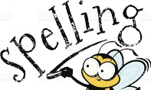
Spellings will be given every Friday and there will be a test each Wednesday. Please do look at the spellings as many times as possible.

Homework will also be handed out on Thursdays and then should be returned by the following Tuesday.

Once again, thank you for your on-going support.

Mrs Blurton, Mrs Barringer, Mrs Sharp and Miss Saville.

