YEAR 2

**Giraffes**

NEWSLETTER NOVEMBER 2024

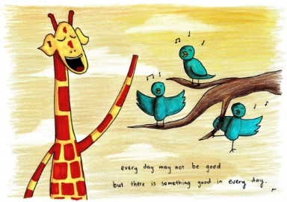

Autumn 2

We hope you have had a great half term break together!

Thank you to all who attended the parents’ evening meetings last term,

it was great to meet you all properly. I hope you left feeling proud!

The final week was so much fun with our Book Week, and we loved seeing

all the children’s costumes.

Beachcombers

This half term we will continue with our topic and will investigate coasts and erosion of coastlines. In History we will continue to look at Victorian seasides.

English

In English we will be using a new and exciting text called ‘A House for a Hermit Crab’ by Eric Carle alongside information books and other stories with familiar settings to help us to learn more about our seaside and coasts.

Maths

In Maths, we will be revising multiplication and then moving on to division and measurement. We will also consolidate our addition and subtraction knowledge and apply these skills in solving worded problems. Please keep practising times tables at home as it really is noticeable in school.

Weekly Routines

PE continues to be on **MONDAYS, TUESDAYS and THURSDAYS**- children should come to school wearing their PE kit. There have been quite a few children who have not had their earrings covered with tape, please **ensure** this is done before coming to school or they will need to take their earrings out for the lesson.

Spellings will be sent home on **Mondays** and the children will be tested on the **Friday**.

Homework is set on a **Thursday** and is due in by the following **Tuesday**.

Forest Schools is on a Wednesday and now the weather has become a little colder and wetter, they will not be able to participate if they don’t have a change of shoes. They seem to really love these sessions!

[](http://www.google.co.uk/url?sa=i&rct=j&q=&esrc=s&source=images&cd=&cad=rja&uact=8&ved=0CAcQjRw&url=http://www.clipartof.com/gallery/clipart/calendar.html&ei=ZiZuVYfQI8LWUZHGgLgH&bvm=bv.94911696,d.d24&psig=AFQjCNE-qZUVHjlKhjacVDR_W7ZDg1AvNA&ust=1433368442087539)

How can you help your child?

* Listen to them read each week Please make a note in their reading record when they have read to you as they love getting stickers for reading at home (this can be your signature or a short comment).
* Ask them questions about what they have read.
* Encourage them to practise their spellings every day.
* Support them in completing their homework if they need help.
* Practise 2, 5, 10 times tables as much as possible!

Key Dates:

* 15th November- Children in Need PJ day
* 27th November – Christmas Fair
* 10th and 11th December – Nativity performances
* 18th December – Christmas dinner day
* Friday 20th December – Last day of the half term.

Please do not hesitate to ask any questions you have or to have a chat about any concerns you might have. I just ask that you wait until the class is dismissed so I can ensure everyone is safely with their adults.

I am so pleased with the progress the children are making, and I thank you for your ongoing support.

Mrs Burns