Young Minds - The UK’s leading charity fighting for children and young people's mental health. Resources for parents including an A-Z guide with advice on how to help your child with specific mental health conditions, and life events which might be negatively affecting their wellbeing.
https://www.youngminds.org.uk/

Kooth - Provides free, safe and anonymous online support and counselling. The whole team are made up of friendly and experienced individuals who want to help you.
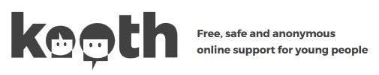

https://www.kooth.com/

Thinkuknow - The education programme from NCA-CEOP, a UK organisation which protects children both online and offline, providing advice about staying safe when you're on a phone, tablet or computer.

https://www.thinkuknow.co.uk/

Action for Happiness - Producing monthly calendars that are packed with actions you can take to help create a happier and kinder world.
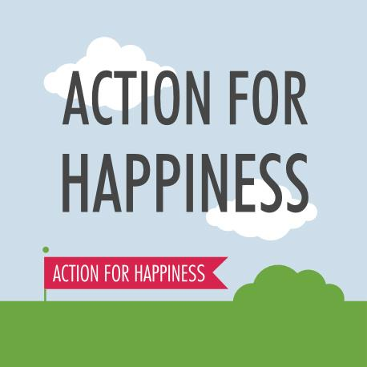
https://actionforhappiness.org/

The Childhood Bereavement Network - Includes support, advice and resources on supporting a bereaved child or young person.
https://childhoodbereavementnetwork.org.uk/

Teen Sleep Hub - Offers advice, support and tips on achieving a good night's sleep.
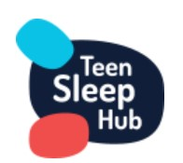
https://teensleephub.org.uk/

