Barleyhurst Park Primary School

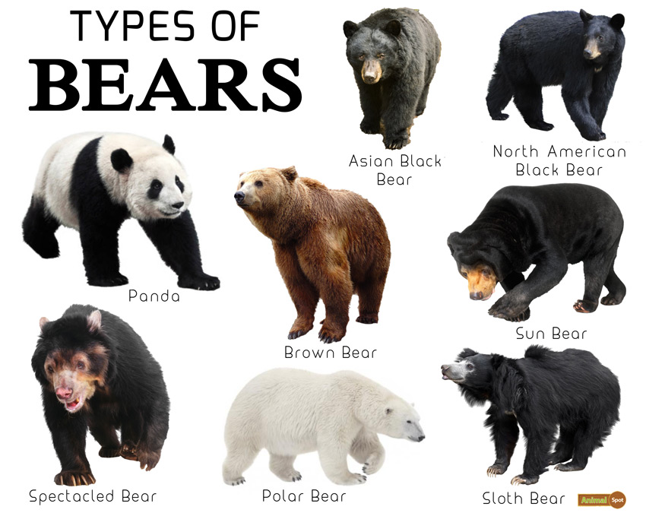

“Lovely Lions look, listen and learn. We can do it, we
will do it, we will do it well.”
'Bears'
Lion Class

Welcome back lovely lions! I hope you had a lovely Christmas holiday. The children loved the last two festive weeks in school before Christmas and the Santa’s Grotto in particular! We will have another busy and exciting half-term ahead of us. We cannot wait to start our new topic, ‘Bears’.
Each week will have a different focus. We will be covering ‘Goldilocks and the Three Bears’ as part of our Talk for Writing curriculum and we will learn about brown and polar bears. The children will also have an opportunity to compare old and new teddy bears and bring their own teddies to school for a picnic!
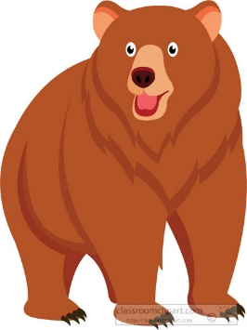
What the children will be learning:
Communication, Language and Literacy
- Continue the development of letter recognition and formation
- Development of reading skills and enjoyment of books
- Sequencing and retelling ‘Goldilocks and the Three Bears’ using actions as part of our ‘Talk for Writing’ curriculum
- Writing new lines for the ‘Polar Bear, polar bear, what do you hear?’ story
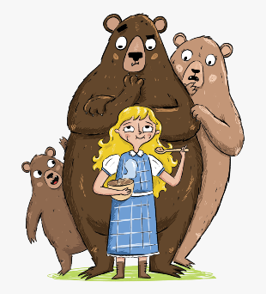
- Develop their writing skills through factual sentences, labelling and short stories
- Learning to write their name independently from memory
- Learning new high frequency words

Mathematical development
- Comparing length/height and weight using comparative vocabulary
- Reading, writing, ordering and counting numbers 1 to 20.
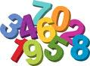
- Exploring composition of numbers to 10
- Learning to solve addition sentences within 10
- Solving missing numbers in number patterns

Understanding of the world
- Find out about real bears and their habitats
- Compare their own teddies with old teddy bears from the past
- Make and taste their own porridge and teddy bear biscuits
- Learn about the Chinese New Year
Expressive arts and design
- Draw and paint teddy bears from observation
- Construct with different materials
- Learn through play in our Three Bears’ Cottages inside and outdoors, as well as the North Pole and Chinese takeaway areas later on
- Making a Chinese Lantern and a Chinese dragon
- Continue to learn new songs and use different instruments

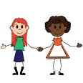
Personal, social and emotional development
- Activities to encourage independence, concentration and confidence
- Building self-esteem through positive feedback, reward charts, star reader and writer rewards, reward wall (yellow achievement stars from home), star of the week assemblies.
- Continuing to follow our classroom rules and routines
- Thinking about our own community
- Forming relationships within our classroom
- Managing emotions

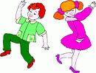
Physical development
- Developing fine motor skills through a variety of activities: bead threading, using finger puppets, cutting and using loose parts
- Developing an awareness of space
- Using large play equipment safely
- Travelling, using different parts of the body
- Focusing on fitness training
- Responding to music with a dance
- Developing the understanding of healthy eating

Your support
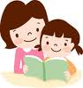
We hope you can assist your child in their learning by:
- Reading with them regularly and writing a brief comment in their reading record
- Helping them to learn their sounds and high frequency words weekly
- Reminding them to bring their bookbag to school every day
- Ensuring all items of clothing are named
- Ensuring that they come to school wearing the correct P.E. kit on Tuesdays, Wednesdays and Fridays
- Completing the Learning Journal task at home. It is posted through Tapestry every Friday or Monday
- Useful websites: www.topmarks.co.uk, (early years section) www.bbc.co.uk/cbeebies , www.phonicsplay.co.uk (phase 1 and 2 games), www.iboard.co.uk (4-7 years), Thank you for your continued support.

Mrs Wheeler and the Foundation team

