Monkeys
November 2023

Welcome back to another half term in Year 3!
After such a hard-working first half of the autumn term, it is difficult to believe that we can work even harder…but I’m sure the children are up to the challenge! Last half term our main focuses, as a class, were to settle back into our new classroom setting with the faster, more grown-up pace of KS2.
I really enjoyed speaking to you over the course of the last week of last half term to discuss your child’s progress so far. Thank you for your continued support with homework, spellings and reading.
This term in English and maths…
The children loved reading ‘Ottoline and the Yellow Cat’ last half-term and the work they produced was fantastic! This half-term our first focus will be Greek myths, which fits perfectly with our Ancient Greek topic. We will read and explore different stories and end the term by writing our own versions.
I can’t wait to see their finished pieces. 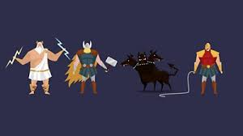

In maths we will continue to use our Maths No-Problem resources and will continue with our addition and subtraction methods. After this there will be a massive focus on our times tables so lots of practise at home would be wonderful.

This term in Topic…
After some wonderful lessons in the first half term, the children will continue their quest to find out about life in Ancient Greece. We will be studying Greek influences on our modern world, which will include the alphabet, ancient Olympic games and theatre. In our art lessons, we will be designing and creating our own Greek pots.
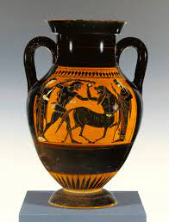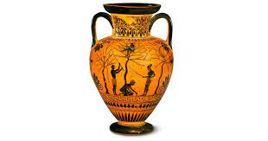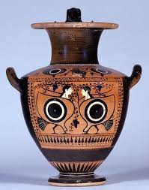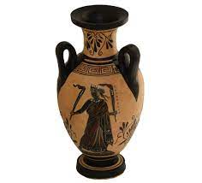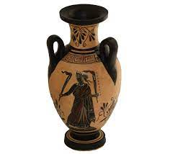
This term, I have a student teacher, who is currently undergoing her last placement before she qualifies. Although she will be teaching the class for some of the time, I will be overseeing all of her planning and delivery.
As ever, if you have any concerns or would like to discuss any issues arising within school then please arrange for an appointment or a phone call and I would be happy to help.
Kind regards,
Mrs Burns

